A
Industrial Training
Report on
"Fortify & Detect: Sophos Firewall Hardening and
SOC-Based Threat Detection Pipeline Development"
Submitted in Partial Fulfilment for the award of the Degree of
Bachelor of Technology
in
Computer Science Engineering (Cyber Security)

2026 - 2027
Submitted To: Submitted By:
Dr. Chirag Arora Pari Tenguriya
Head of Department B.Tech, 4th Year
23EACCC040
ARYA COLLEGE OF ENGINEERING, JAIPUR
DEPARTMENT OF CYBER SECURITY
CERTIFICATE
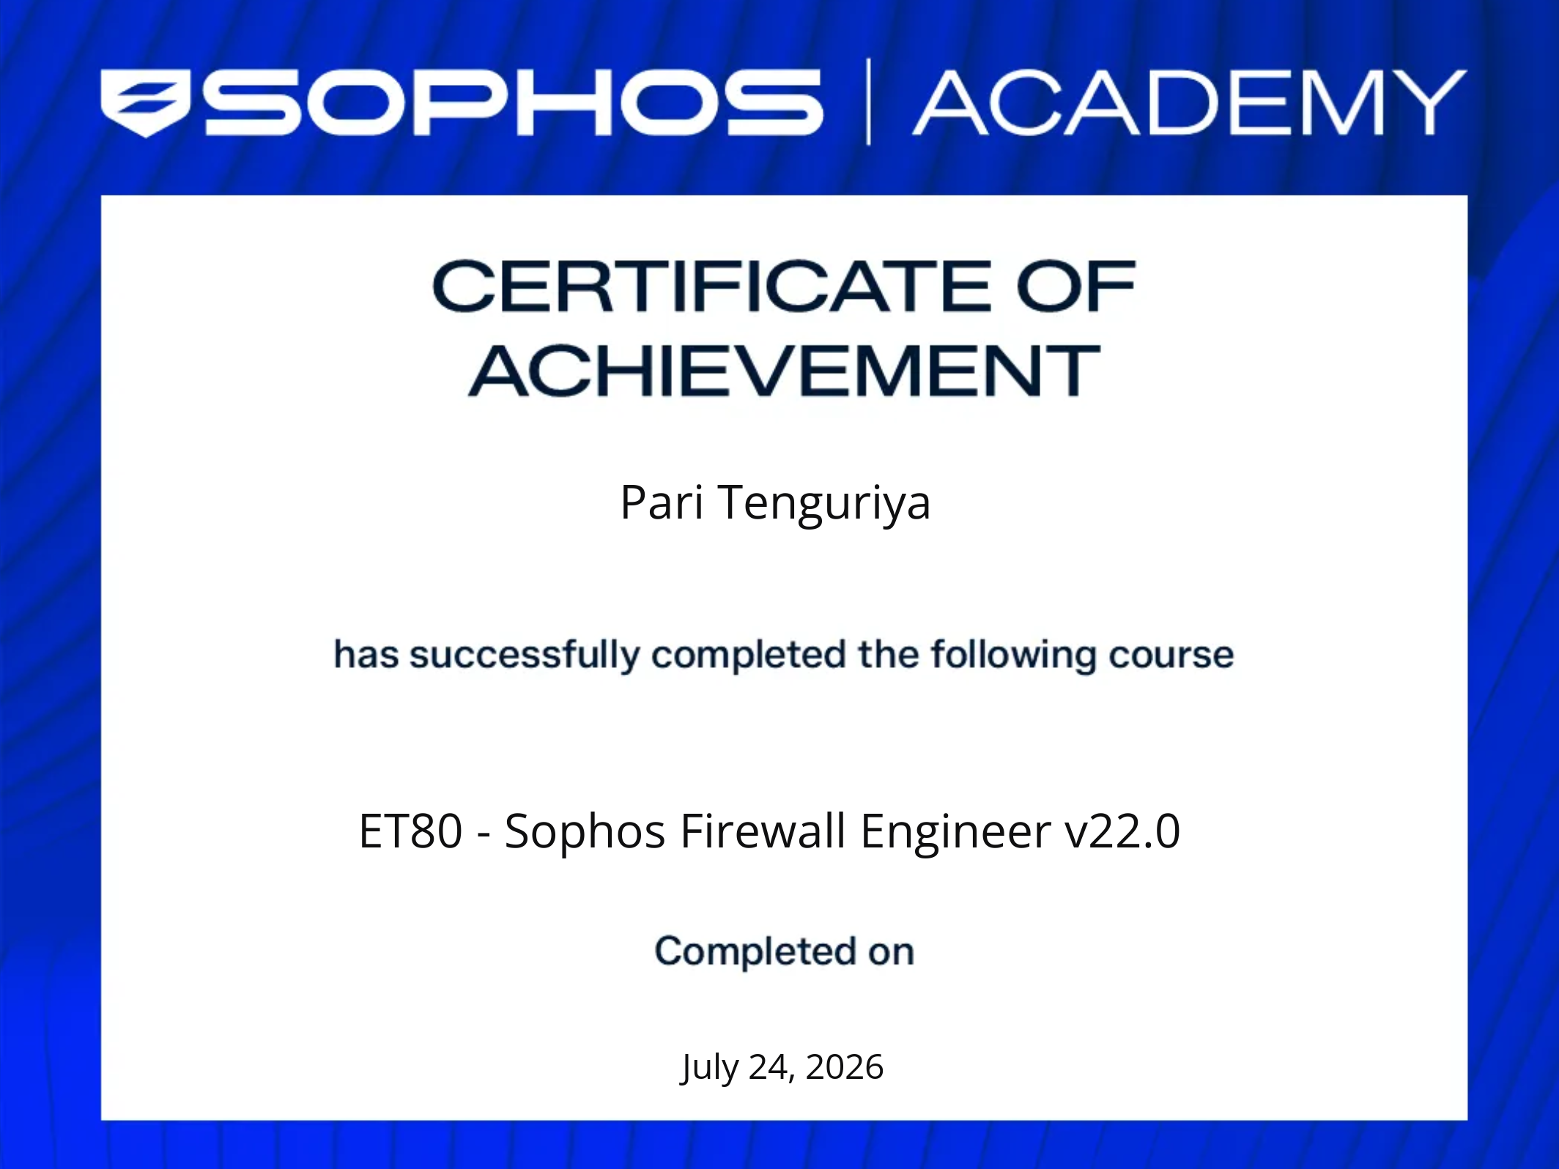
CERTIFICATE
ARYA COLLEGE OF ENGINEERING
SP-40, RIICO Industrial Area, Kukas, Delhi Road, Jaipur, Rajasthan – 302028
Department of Cyber Security
This is to certify that the work, which is being presented in the Industrial Training Report taken at “Rise Tech Software Pvt. Ltd.”, submitted by Pari Tenguriya, a student of final year (VII Semester) B.Tech. in Computer Science Engineering (Cyber Security), as a partial fulfilment for the award of the degree of Bachelor of Technology, is a record of the student’s own work, carried out under the guidance of the undersigned, and found satisfactory for submission.
Mr. Chirag Arora
HOD, Department of Cyber Security
DECLARATION
I hereby declare that the work presented in this Industrial Training Report titled “Fortify & Detect: Sophos Firewall Hardening and SOC-Based Threat Detection Pipeline Development”, submitted in partial fulfilment of the requirements for the award of the degree of Bachelor of Technology in Computer Science Engineering (Cyber Security) to the Department of Cyber Security, Arya College of Engineering, Rajasthan Technical University, is a record of my own work carried out under the guidance of Mr. Chirag Arora.
I further declare that the matter presented in this report has not been submitted by me, in part or in full, for the award of any other degree of this or any other university.
Pari Tenguriya
23EACCC040
ACKNOWLEDGEMENT
I wish to express my deep sense of gratitude to my Industrial Training supervisor, Mr. Dinesh Sharma, Rise Tech Software Pvt. Ltd., for his valuable guidance and support throughout the duration of the training, from its inception to completion, including support for literature survey and critical review of my work.
I would like to express my sincere thanks to Dr. Arvind Agarwal, Chairman, Arya Group of Colleges, and Dr. Puja Agarwal, Vice Chairman, Arya Group of Colleges, for providing an excellent infrastructure and environment for overall development.
I express my sincere thanks to Dr. Surendra Sharma, Director, Arya Group of Colleges, for his kind cooperation and support towards the completion of this report.
I express my sincere thanks to Dr. Himanshu Arora, Principal, Arya College of Engineering, for his kind cooperation and support towards the completion of this report.
I also express my deepest thanks to Dr. Chirag Arora, HOD, Department of Cyber Security, for his technical guidance and support in fulfilling the requirements of this report.
I extend my thanks to the supporting Cyber Security faculty, especially my coordinator Dr. Monica Lamba, for her constant encouragement throughout the completion of this report.
Finally, my warm thanks to Arya College of Engineering for providing me the opportunity to undertake this Industrial Training and enhance my learning in the field of network security.
Pari Tenguriya
23EACCC040
TABLE OF CONTENTS
Title Page no
Cover Page i
Certificate (Company) ii
Certificate (College) iii
Declaration iv
Acknowledgement v
Table of Contents vi
List of Figure ix
List of Tables xi
List of Abbreviations xii
1. Introduction 1-3
1.1 About Internship Program 1
1.2 Objectives of Training 2
1.3 Scope of Training 2
2. Network Security Fundamentals 4-7
2.1 CIA Triad 4
2.2 DAD Triad 4
2.3 AAA Framework 5
2.4 Defense in Depth 5
2.5 Common Threats & Attack Vectors 6
2.6 Need for Firewalls 7
3. Firewall Technology 8-9
3.1 Packet Filtering 8
3.2 Stateful Inspection 8
3.3 Next-Generation Firewall (NGFW) 9
4. Sophos Firewall — Architecture 10
4.1 Overview & Features 10
4.2 Deployment Modes 10
4.3 Zones & Interfaces 11
5. Sophos Firewall — Configuration 12-13
5.1 Initial Setup & Licensing 12
5.2 Interface & Zone Configuration 12
5.3 IP Addressing Scheme 12
5.4 Routing / DNS / DHCP Configuration 12
6. Security Policy Implementation 14-17
6.1 Firewall Rules & NAT 14
6.2 User Authentication (AAA link) 15
6.3 Application Control 15
6.4 Web Filtering & Website Blocking 16
6.5 IPS & SSL Inspection 16
6.6 Antivirus Protection 16
7. VPN Implementation 18-19
7.1 Site-to-Site VPN 18
7.2 Remote Access VPN 18
8. Monitoring, Logging & Backup 20-21
8.1 Dashboard, Logs, Reports 20
8.2 Backup & Restore 20
9. Project Introduction 22-24
9.1 Motivation 22
9.2 Objective & Scope 22
9.3 Tools Used 23
10. Project Architecture 25-28
10.1 System Diagram (Sophos → Wazuh → MISP) 25
10.2 Network / IP Design 26
10.3 Component Roles & Justification 26
11. Implementation 29-33
11.1 Sophos Syslog Configuration 29
11.2 Wazuh Decoder & Rule Authoring 29
11.3 Endpoint Telemetry (Sysmon + Wazuh Agent) 30
11.4 Sigma Rules mapped to MITRE ATT&CK 31
11.5 MISP Threat Intel Integration 33
12. Testing & Results 34-36
12.1 Test Scenarios 34
12.2 Screenshots & Evidence 35
12.3 Detection Latency / Alert Accuracy 35
13. Practical Work Summary 37-38
13.1 Lab Network Setup 37
13.2 Troubleshooting Cases Faced 37
14. Industry Knowledge & Learning Outcomes 39-40
14.1 Technical Skills Gained 39
14.2 Challenges Faced & Solutions 39
14.3 Limitations of Project 40
15. Conclusion & Future Scope 41-42
References 43
Appendix
A. Internship Offer Letter
B. Company Certificate
C. Project Screenshots & Command Outputs

LIST OF FIGURES
Fig. No. | Figure Name | Page No.
2.1 | CIA Triad — Confidentiality, Integrity, Availability | 5
2.2 | DAD Triad — Disclosure, Alteration, Destruction | 6
2.3 | AAA Framework — Authentication/Authorization/Accounting | 8
2.4 | Defence in Depth — Layered Security Model | 9
2.5 | Common Attack Vectors — Overview Diagram | 10
3.1 | Packet Filtering — Rule Match Logic | 12
3.2 | Stateful Inspection — Connection State Table | 13
3.3 | NGFW — Layered Feature Comparison | 15
4.1 | Sophos XG Firewall — Dashboard Overview | 17
4.2 | Zones & Interface Mapping | 18
5.1 | Initial Setup Wizard — Licensing Screen | 19
5.2 | IP Addressing Scheme Diagram | 21
5.3 | DNS Configuration Screen | 22
6.1 | Firewall Rule Evaluation Order — First-Match, Default-Deny | 23
6.2 | User Authentication Setup | 25
6.3 | Application Control Policy | 26
6.4 | Web Filtering | 26
6.5 | IPS & SSL Inspection Configuration | 28
6.6 | Antivirus Protection Screen | 29
7.1 | Site-to-Site VPN Topology | 31
7.2 | Remote Access VPN Topology | 32
8.1 | Sophos Dashboard & Reports | 33
8.2 | Backup & Restore Configuration | 34
9.1 | Tool Stack | 36

List of Tables
S. No. | Table Name | Page No.
1 | Training Planner | 1
2 | CIA Triad vs DAD Triad — Comparative Mapping | 7
3 | Comparison of Firewall Generations — Packet Filtering vs Stateful Inspection vs NGFW | 11
4 | IP Addressing Scheme | 20
5 | Sample Firewall Rule Base | 24
6 | VPN Comparison — Site-to-Site vs Remote Access | 32
7 | Tools Used in Project — Tool, Purpose, Version | 35
8 | Risk Matrix | 37
9 | Security Information and Event Management Lab Specifications | 39
10 | Tool stack with model | 43
11 | Component Roles & Justification | 44
12 | Sigma Rule to MITRE ATT&CK Mapping | 49
13 | Test Scenarios —Expected vs Actual Results | 53
14 | Latency & Alert Accuracy Metrics | 56
LIST OF ABBREVIATIONS

Abbreviation | Full Form
AAA | Authentication, Authorization, Accounting
ACE | Arya College of Engineering
ATT&CK | Adversarial Tactics, Techniques & Common Knowledge
AV | Antivirus
B.Tech | Bachelor of Technology
CIA | Confidentiality, Integrity, Availability
DAD | Disclosure, Alteration, Destruction
DDoS | Distributed Denial of Service
DHCP | Dynamic Host Configuration Protocol
DNS | Domain Name System
DoS | Denial of Service
IP | Internet Protocol
IPS | Intrusion Prevention System
IT | Information Technology
MISP | Malware Information Sharing Platform
MITM | Man-in-the-Middle
NAT | Network Address Translation
NGFW | Next-Generation Firewall
SIEM | Security Information and Event Management
Sysmon | System Monitor
SSL | Secure Sockets Layer
XDR | Extended Detection and Response

1. Introduction
1.1 About Internship Program
As part of the curriculum requirement for the degree of Bachelor of Technology in Computer Science Engineering (Cyber Security), I undertook an Industrial Training Program at Rise Tech Software Pvt. Ltd. (RTS), Jaipur — an ISO/IEC 20000-1:2018, ISO 9001:2015, and ISO/IEC 27001:2013 certified IT solutions provider. I was formally inducted into the program, designated as Trainee Intern, through an official offer letter dated 25 May 2026, for the domain of Sophos Firewall Configuration and Network Security.
The training program spanned a total duration of 45 days, structured in two phases: a 15-day in-house training conducted at the RTS office premises under the supervision of certified industry professionals and technical mentors, followed by 30 days of practical industrial exposure across private and government sector client organizations. This second phase provided direct, hands-on exposure to enterprise security operations, firewall management practices, and IT infrastructure environments in a live operational setting.
This report, and the extended project presented in Chapters 9 to 15, are built directly on the technical foundation established during this training.
The following table summarizes the week-by-week structure of the 45-day training program, mapping each phase to the corresponding chapters of this report:
Week | Phase | Primary Activity | Report Reference
Week 1–2 | In-house training | Network security fundamentals, firewall theory, Sophos XG architecture orientation | Chapters 2–4
Week 3 | In-house training | Sophos initial setup, licensing, interface/zone configuration, IP addressing | Chapter 5
Week 4–5 | Industrial exposure | Security policy implementation — rules, NAT, authentication, application/web control, IPS, SSL, AV | Chapter 6
Week 6 | Industrial exposure | VPN implementation, monitoring/logging configuration, backup procedures | Chapters 7–8
Week 6–7 (parallel) | Self-directed project | SOC lab design, Wazuh/MISP deployment, decoder and rule authoring, testing, documentation | Chapters 9–13
Table -1. Training Planner
Note: Weeks 6–7 of the self-directed project ran in parallel with the closing stage of the industrial exposure phase rather than strictly after it, since the project's perimeter-telemetry requirement depended on the syslog export configuration only finalized toward the end of the training (Chapter 8.1).
1.2 Objectives of Training
The Industrial Training was undertaken with the following objectives:
- To gain hands-on exposure to enterprise-grade network security infrastructure, specifically the Sophos XG (SFOS) firewall platform, within a live operational environment.
- To understand the practical workflow of firewall deployment — interface and zone configuration, IP addressing, routing, and DNS/DHCP setup.
- To acquire working knowledge of security policy implementation, including firewall rule authoring, NAT configuration, application control, web filtering, intrusion prevention (IPS), SSL inspection, and antivirus integration.
- To study VPN technologies — Site-to-Site and Remote Access — as implemented for secure enterprise connectivity.
- To develop familiarity with monitoring, logging, and backup/restore procedures essential to firewall administration.
- To bridge classroom-taught network security theory with its real-world enterprise application, in line with the B.Tech Cyber Security curriculum.
- To build a technical foundation sufficient to independently extend firewall-level security knowledge into a broader detection-engineering context — carried forward in the project presented in Chapters 9 to 15 of this report.
1.3 Scope of Training
The scope of this Industrial Training is confined to network perimeter security — specifically the configuration and administration of the Sophos Firewall platform, as practiced at Rise Tech Software Pvt. Ltd. and its associated client sites. The training covered firewall architecture and deployment modes, zone- and interface-based network segmentation, security policy configuration (rules, NAT, application control, web filtering, IPS, SSL inspection, antivirus), VPN implementation, and system monitoring, logging, and backup procedures — detailed across Chapters 2 to 8 of this report.
In accordance with the confidentiality obligations stated in the internship offer letter, client-specific configurations, credentials, network topologies, and IP addressing schemes encountered during the 30-day practical exposure phase are not reproduced in this report. All configuration examples and screenshots presented herein are drawn from a controlled, non-production lab environment.
The scope of the training, as originally defined, did not extend to detection engineering, SIEM deployment, or threat intelligence integration. These areas were independently explored through a self-directed project — presented in Chapters 9 to 15 of this report — undertaken to extend the firewall-centric skills gained during training into a complete Security Operations Center (SOC) detection pipeline.
It is worth stating explicitly why this extension was undertaken and why it is included in an Industrial Training Report rather than kept as a separate submission. Firewall administration, the subject of the industrial training itself, is one function within a SOC — typically the perimeter-defence function. It does not, on its own, generate correlated alerts, enrich indicators against threat intelligence, or map observed activity to known adversary technique. This extension was therefore not designed as an unrelated addition, but as the logical next question raised directly by the training: once the firewall is correctly configured and generating logs , what happens to those logs, and how would a SOC actually use them to detect an attack in progress? Chapters 9 to 15 answer that question using the exact log source configured in Chapters 1 to 8 as their starting point, and is reported alongside the training specifically because the two halves demonstrate a single, connected skill progression — perimeter configuration feeding into detection engineering — rather than two unrelated bodies of work placed under one cover.
2. Network Security Fundamentals
2.1 CIA Triad
The CIA Triad is the foundational model defining the three core objectives of information security. Every security control deployed and described in this report — firewall rule, encryption, access policy — exists to serve one or more of these three goals.
- Confidentiality: ensuring information is accessible only to authorized entities, enforced through encryption (AES, TLS), access control lists, and authentication mechanisms.
- Integrity: ensuring information remains accurate and unaltered, enforced through hashing (SHA-256), digital signatures, and checksums.
- Availability: ensuring authorized users have reliable and timely access to resources, enforced through redundancy, load balancing, DDoS mitigation, and backup/restore procedures.
In the context of this report, the Sophos firewall rule base directly enforces Confidentiality by blocking unauthorized traffic and Integrity through deep packet inspection and IPS signatures, while High Availability (HA) deployment mode, discussed in Chapter 4.2, addresses Availability.
It is worth noting that the CIA Triad, while foundational, is not universally treated as exhaustive: some frameworks extend it further — for instance, the Parkerian Hexad adds Possession, Authenticity, and Utility, and several security texts treat Non-repudiation as a related, distinct objective. The CIA Triad is best understood as the minimum foundational model rather than a complete taxonomy of security goals.
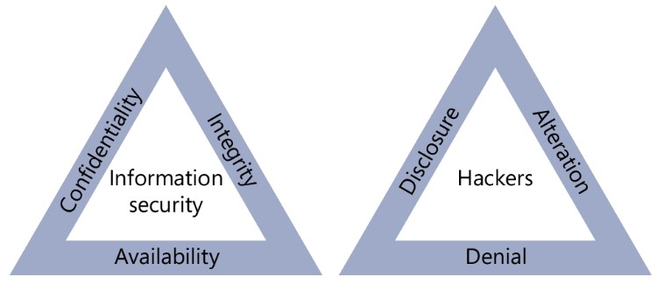
Fig- 2.1 CIA Triad — Confidentiality, Integrity, Availability
2.2 DAD Triad
Where the CIA Triad defines the defender’s objectives, the DAD Triad — Disclosure, Alteration, Destruction — defines the attacker’s objectives. It is the direct inverse of CIA, and pairing the two models illustrates both sides of the security equation: what is being protected, and what results when that protection fails.
Each CIA pillar has a corresponding DAD counterpart. Confidentiality is broken by Disclosure — for example, a data breach or packet sniffing attack that exposes protected information. Integrity is broken by Alteration — for example, a Man-in-the-Middle attack that tampers with data in transit, or unauthorized defacement of a system. Availability is broken by Destruction — for example, a ransomware attack, a Distributed Denial of Service attack, or the deliberate wiping of storage media.
Every attack technique discussed later in this chapter (Section 2.5) and every test scenario documented in Chapter 12 maps to at least one DAD outcome. The defensive controls implemented throughout this report exist specifically to prevent one or more of these outcomes, which is the underlying justification both for firewall deployment (Chapters 4 to 8) and for the detection pipeline built later in this report (Chapters 9 to 15).’

Fig – 2.2 DAD Triad — Disclosure, Alteration, Destruction

Concept | CIA Triad (Security Goal) | DAD Triad (Security Failure)
Data Privacy | Confidentiality | Disclosure
Data Accuracy | Integrity | Alteration
System Uptime | Availability | Destruction
Table 2- CIA Triad vs DAD Triad — Comparative Mapping
2.3 AAA Framework
AAA — Authentication, Authorization, Accounting — governs the identity and access lifecycle for any user or device interacting with a secured system. Authentication verifies an identity claim, answering the question “who are you?”, typically through a password, digital certificate, biometric factor, or multi-factor combination. Authorization determines what actions an authenticated identity is permitted to perform, answering “what can you do?”, typically enforced through role-based access control (RBAC) or group policy. Accounting records what an identity actually did, answering “what did you do?”, typically implemented through system logs, audit trails, or RADIUS accounting records.
Two protocols are commonly used to implement AAA in enterprise network devices. RADIUS, operating over UDP ports 1812 and 1813, combines authentication and authorization into a single exchange and is commonly used for VPN and Wi-Fi access control. TACACS+, operating over TCP port 49 and developed by Cisco, separates all three AAA functions into independent processes and is used primarily for administrative access to network devices.
An illustrative (non-client-specific) Cisco IOS AAA configuration is shown below for reference:
aaa new-model
aaa authentication login default group tacacs+ local
aaa authorization exec default group tacacs+ local
aaa accounting exec default start-stop group tacacs+
tacacs-server host 192.168.1.10 key CiscoSecret123
In the context of this report, Chapter 6.2 (User Authentication) implements this same framework on the Sophos platform: local or Active-Directory-bound user login on the firewall constitutes Authentication, the binding of firewall rules and policies to user groups constitutes Authorization, and the Sophos log viewer and reporting module constitutes Accounting.
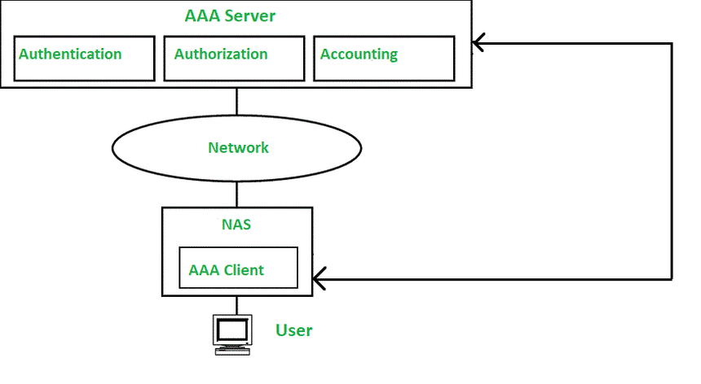
Fig -2.3 AAA Framework — Authentication / Authorization / Accounting

2.4 Defense in Depth
Defense in Depth is the security principle that no single control should be assumed sufficient on its own — instead, multiple independent layers of control are deployed so that the failure or bypass of one layer does not compromise the entire system. A commonly cited layered model, from outermost to innermost, proceeds as follows: the Perimeter layer (firewall, IPS, VPN gateway), the Network layer (VLAN segmentation, access control lists), the Host layer (antivirus, host intrusion detection, OS hardening and patching), the Application layer (web application firewall, input validation, secure coding practice), and finally the Data layer (encryption, data-loss prevention, access control).
A common misconception is that deploying a firewall alone constitutes Defense in Depth. It does not — a firewall represents a single layer (Perimeter) of the model. This report demonstrates genuine layering in practice: the Sophos firewall with its integrated IPS and antivirus modules (Chapters 4 to 8) provides the Perimeter layer, while the Wazuh- and Sysmon-based detection pipeline built in Chapters 9 to 15 provides an independent Host layer — two distinct layers rather than a single point of failure.
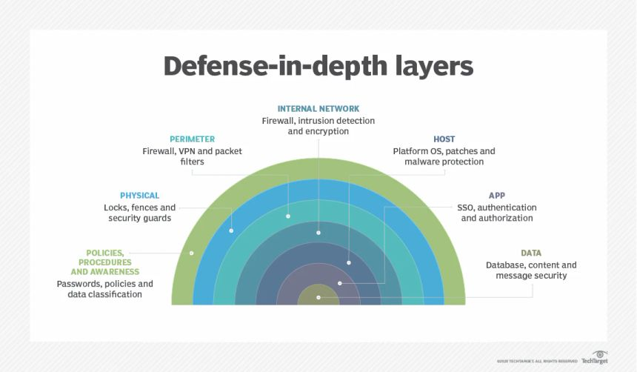
Fig - 2.4 Defense in Depth — Layered Security Model
2.5 Common Threats & Attack Vectors
This section outlines the principal categories of threat relevant to enterprise network security, each mapped to its corresponding DAD-triad impact as introduced in Section 2.2.
- Malware — malicious code such as viruses, worms, trojans, and ransomware, typically delivered via email attachments or drive-by downloads, capable of causing both Disclosure (data theft) and Destruction (data or system loss).
- Phishing — deceptive communication, most commonly spoofed email or social engineering, designed to trick a user into disclosing credentials or sensitive information, resulting in Disclosure.
- Man-in-the-Middle (MITM) — interception and/or alteration of communication between two parties without their knowledge, commonly executed through ARP spoofing, rogue access points, or SSL-stripping, resulting in both Disclosure and Alteration.
- Denial of Service / Distributed Denial of Service (DoS/DDoS) — volumetric traffic floods or protocol-exhaustion attacks intended to overwhelm a target resource and deny service to legitimate users, resulting in Destruction of availability.
- Insider Threat — a threat originating from within the organization, whether through malicious privileged misuse or negligent handling of data, capable of resulting in Disclosure, Alteration, or both.
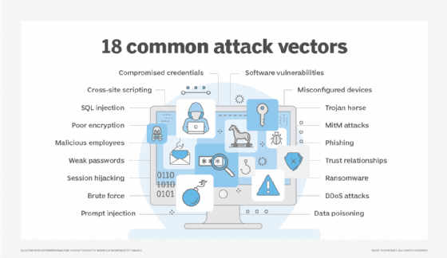
FIG - 2.5 Common Attack Vectors — Overview Diagram
2.6 Need for Firewalls
Given the threat landscape outlined in Section 2.5 and the DAD-triad consequences defined in Section 2.2, a firewall is deployed as the first line of enforced perimeter control. It filters traffic by IP address, port, protocol, and increasingly by application; blocks known-bad and unauthorized traffic before it reaches internal assets; and generates the logs that feed the Accounting layer of the AAA framework described in Section 2.3.
A firewall alone does not address every threat class — insider threats and endpoint-resident malware, in particular, require host-level controls in line with the Defense-in-Depth model of Section 2.4. Nevertheless, the firewall remains the most foundational and widely deployed network security control, which is why firewall technology in general, and its Sophos-specific implementation in particular, form the subject of the remainder of Chapters 3 to 8 of this report.
3. Firewall Technology
3.1 Packet Filtering
Packet filtering is the earliest and most fundamental firewall technology, operating primarily at Layer 3 (Network) and Layer 4 (Transport) of the OSI model. A packet-filtering firewall examines each individual packet in isolation against a static rule set, commonly referred to as an Access Control List (ACL), defined by criteria such as source IP address, destination IP address, source port, destination port, and transport protocol (TCP, UDP, or ICMP). Based on whether the packet matches a rule, it is either permitted (ALLOW) or discarded (DENY).
Because packet filtering evaluates each packet independently, without any awareness of the connection or session to which it belongs, it is described as stateless. This design makes it fast and resource-efficient, well suited to high-throughput environments, but also fundamentally limited: it cannot distinguish a legitimate reply packet belonging to an already-established connection from a spoofed or unsolicited packet crafted to satisfy the same static rule.

Feature | Packet Filtering | Stateful Inspection | Next-Generation (NGFW)
OSI Layer | Layer 3 and 4 | Layer 3 and 4 | Up to Layer 7
Traffic Context | Checks each packet blindly | Remembers active connections | Identifies apps and users
Threat Prevention | None | None | Deep packet inspection and IPS
Table 3- Comparison of Firewall Generations
An illustrative (generic, non-client-specific) rule set is shown below for reference:
ALLOW TCP Source: Any Destination: 192.168.1.0/24 Port: 443
DENY TCP Source: Any Destination: Any Port: 23
ALLOW UDP Source: Any Destination: 192.168.1.10 Port: 53
The principal limitations of packet filtering are its lack of application-layer visibility, its vulnerability to IP spoofing and packet-fragmentation attacks, and the fact that its rule sets become increasingly unmanageable as network complexity grows. Despite these limitations, packet filtering remains the foundational layer on which every modern firewall — including the Sophos XG platform used throughout this training — builds its more advanced inspection capabilities.

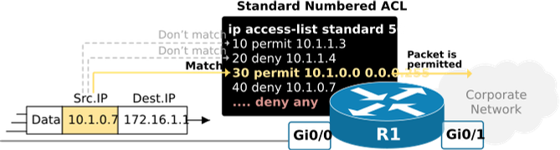
Fig - 3.1 Packet Filtering — Rule Match Logic
3.2 Stateful Inspection
Stateful inspection, introduced in the early 1990s as an evolution of packet filtering, addresses the central weakness of the stateless model by maintaining a state table that tracks the status of every active connection passing through the firewall — including source and destination IP-port pairs, TCP sequence numbers, and connection state (SYN, SYN-ACK, ESTABLISHED, FIN, and so on).
Under this model, only the first packet of a new connection is evaluated against the full rule base. Once the connection is permitted and an entry is created in the state table, all subsequent packets belonging to that same session are matched directly against the state table entry rather than being re-evaluated against every rule, which significantly improves both performance and accuracy. Reply traffic is automatically permitted where it matches an existing, legitimately established session; unsolicited traffic attempting to masquerade as a reply, without a corresponding state-table entry, is dropped.
This state-awareness is what allows a stateful firewall to correctly enforce directional policy — for example, permitting outbound web requests and their corresponding replies while blocking unsolicited inbound connections — without requiring a separate explicit rule to be written for return traffic, a limitation that pure packet filtering could not overcome cleanly. 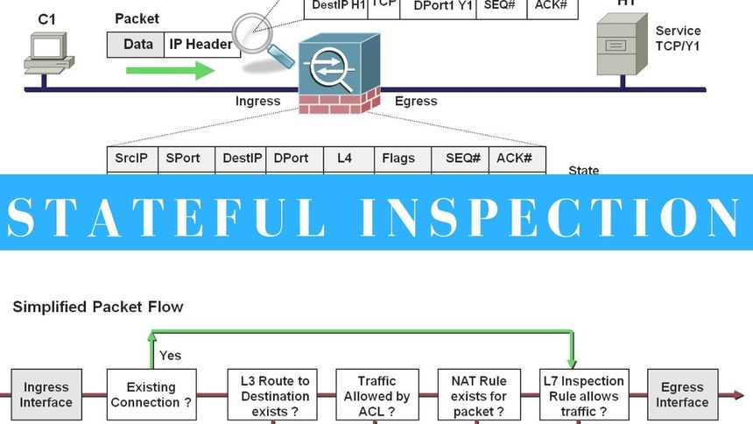
Fig -3.2 Stateful Inspection — Connection State Table

3.3 Next-Generation Firewall (NGFW)
A Next-Generation Firewall (NGFW) extends stateful inspection with deep packet inspection (DPI) and application-layer intelligence, operating up to Layer 7 of the OSI model. Where a stateful firewall can identify only that traffic is running on, for example, TCP port 443, an NGFW can identify what application is actually generating that traffic — inspecting packet payloads, TLS handshake metadata such as the Server Name Indication (SNI) field, and behavioural signatures to distinguish, for instance, a browser session from a VPN tunnel or a file-transfer application riding the same port.
Core Capabilities of an NGFW
The fundamental architecture of an NGFW is defined by the consolidation of multiple advanced security functions into a single, high-performance appliance. These core capabilities include:
- Application Awareness and Control (App-ID): Unlike legacy firewalls that blindly allow traffic on port 443, NGFWs maintain a dynamic, continuously updated database of application signatures. This allows for granular policy enforcement based on the application itself (e.g., allowing access to corporate Microsoft 365, but blocking personal Dropbox uploads), completely independent of the ports or protocols attempting to mask the traffic.
- Integrated Intrusion Prevention System (IPS): Operating inline with the firewall, the IPS scans otherwise permitted traffic for known exploits, vulnerabilities, and malicious payloads. It utilizes a hybrid approach: signature-based detection for known attack patterns (like specific SQL injection strings) and anomaly-based detection to flag irregular protocol behavior that may indicate a zero-day exploit.
- Deep SSL/TLS Inspection: With the vast majority of today's internet traffic encrypted, malware frequently hides within HTTPS streams. An NGFW acts as a secure Man-in-the-Middle (MITM). It decrypts the incoming traffic, inspects the payload for threats, and re-encrypts it before sending it to the destination, ensuring that encrypted threats do not pass through the perimeter invisibly.
- User Identity Awareness (Identity-Based Security): IP addresses are dynamic and easily spoofed. NGFWs shift the security focus from "what is the IP?" to "who is the user?" By integrating with directory services like Microsoft Active Directory (AD), LDAP, or RADIUS, the firewall binds network activity and security policies directly to authenticated users and groups. This is a foundational element for implementing a Zero Trust architecture.
- Integrated Threat Intelligence and Sandboxing: NGFWs continuously cross-reference observed traffic against cloud-based threat intelligence feeds. This provides real-time reputation scoring for malicious IPs, domains, and file hashes. Advanced NGFWs also include sandboxing capabilities, routing suspicious, unknown files to an isolated cloud environment to detonate and observe their behavior before allowing them onto the network.
The Sophos XG Firewall Architecture
Unlike traditional multi-appliance setups, the Sophos XG architecture features a unified policy engine. This means that stateful packet inspection, application control, IPS, web filtering, SSL decryption, and gateway antivirus scanning are all configured and executed within a single firewall rule. Furthermore, Sophos integrates a concept known as Synchronized Security (Security Heartbeat), allowing the firewall to communicate directly with endpoint protection software. If an endpoint is compromised, the XG Firewall can automatically isolate that device from the rest of the network laterally, elevating its capability beyond a standard NGFW.
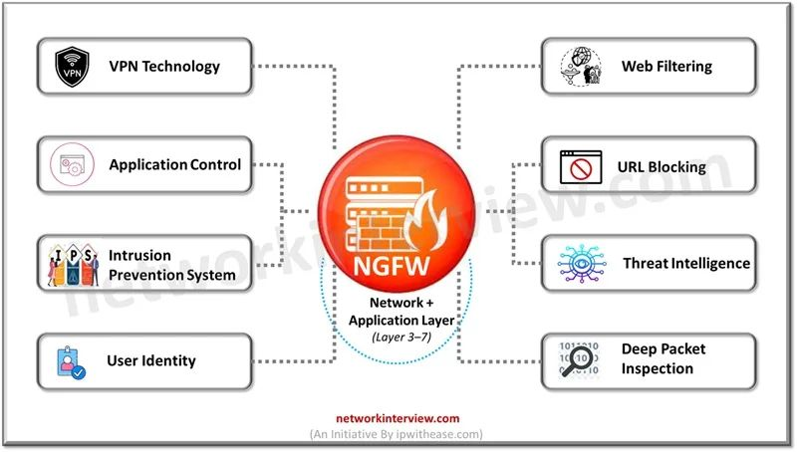
Fig - 3.3 NGFW — Layered Feature Comparison

4. Sophos Firewall — Architecture
4.1 Overview & Features
Sophos XG Firewall, built on the SFOS (Sophos Firewall OS) platform, is a Unified Threat Management (UTM) / Next-Generation Firewall unifying stateful packet inspection, application control, web filtering, IPS, VPN, and antivirus within a single policy engine, administered through a unified WebAdmin console.
At the packet-processing layer, SFOS operates in one of two scanning modes: flow-based (fast-path) mode, which performs single-pass deep packet inspection and is used by default for most traffic profiles favouring throughput; and proxy-based (full-scan) mode, which buffers and reconstructs the complete stream before scanning, reserved for protocols requiring full reassembly at a throughput cost.
A distinguishing architectural feature is the Xstream DPI engine, which performs TLS 1.3-capable inspection with reduced performance penalty relative to legacy proxy-based decryption, and Security Heartbeat — a proprietary protocol exchanging real-time endpoint health status between the firewall and Sophos-managed endpoints, enabling automatic isolation of a compromised host (Synchronized Security) without manual rule intervention. From a detection-engineering standpoint, this heartbeat channel is itself a telemetry source: a degraded (“Red”) heartbeat status logged on the firewall is a high-confidence indicator of endpoint compromise, and would constitute a first-class alert source were Sophos Central integrated with the SIEM — out of scope for the lab environment used in this training, but noted for architectural completeness.
The core feature stack evaluated during this training comprises: stateful and application-aware inspection (Chapter 3), Site-to-Site and Remote Access VPN (Chapter 7), Web and Application Control (Chapter 6), a Snort-derived IPS engine (Chapter 6.5), single/dual-engine antivirus scanning, and SD-WAN policy routing for multi-uplink environments. Cloud sandboxing (Sandstorm) and full Sophos Central cloud management were reviewed conceptually but not exercised, being outside the licensing scope of the training deployment.

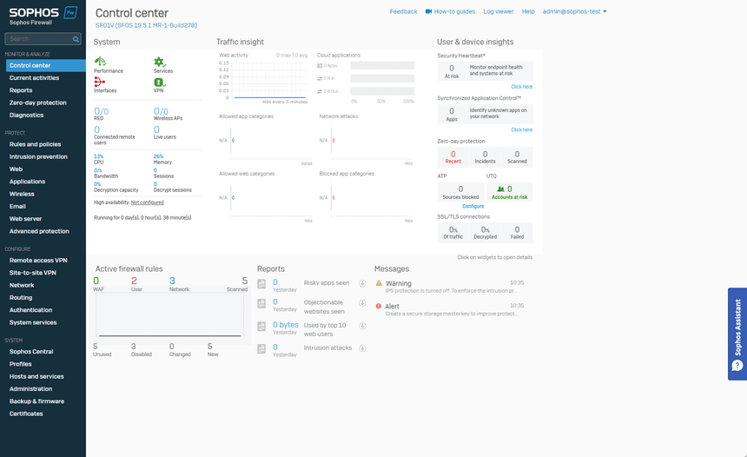
Fig - 4.1 Sophos XG Firewall — Dashboard Overview

4.2 Deployment Modes
SFOS supports three primary deployment modes. Gateway (routed) mode, the default and most feature-complete mode, operates the firewall as a Layer 3 gateway performing inter-zone routing and NAT. Bridge (transparent) mode inserts the firewall inline at Layer 2 without altering existing IP addressing, useful for introducing inspection capability into a network without re-architecting it; NAT and DHCP services are not applicable in this mode. Mixed mode combines both — a subset of interfaces (for example, a DMZ segment) operate in bridge mode while the remainder of the appliance functions in gateway mode.
High Availability (HA) is a related deployment consideration rather than a fourth mode: Active-Passive HA synchronizes configuration and session state between two identical appliances over a dedicated HA link, with the passive unit assuming the WAN/LAN IP addresses on failover — directly addressing the Availability leg of the CIA Triad introduced in Chapter 2.1. The lab environment used for this training was deployed as a single-appliance, non-HA Gateway-mode instance, consistent with the scale of the exercise.
4.3 Zones & Interfaces
SFOS enforces policy at the zone level rather than purely at the interface level: every physical or virtual interface is bound to exactly one zone, and firewall rules are authored as zone-to-zone (more precisely, zone-and-network-object) rules. The default zone set comprises LAN, WAN, DMZ, VPN, WiFi, and Local (traffic originating from or destined to the firewall itself). Zone-based policy allows a single rule to govern every interface sharing a common security posture, rather than requiring a discrete rule per physical port.
Interface types supported include physical ports, VLAN sub-interfaces (802.1Q tagged), bridge pairs/groups, LAG/bond interfaces (802.3ad link aggregation for redundancy and throughput), and IP aliases on a physical interface. In this training, network segmentation was practiced using VLAN sub-interfaces to logically separate the LAN, DMZ, and a dedicated management segment, each bound to its own zone — forming the structural basis for the rule base authored in Chapter 6.
Zone assignment carries significance beyond access control. Sophos syslog messages carry explicit srczone and dstzone fields, which the Wazuh decoder built in Chapter 11.1 parses directly. The zone architecture designed at this stage is therefore not merely an access-control artefact but a data-modelling decision that directly determines the granularity of correlation available later in the SIEM.

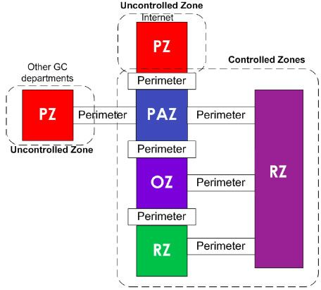
Fig- 4. 2 Zones & Interface Mapping
5. Sophos Firewall — Configuration
5.1 Initial Setup & Licensing
Initial provisioning of SFOS follows a guided Setup Wizard flow: WAN/LAN interface assignment, base network configuration, administrator credential creation, and license activation against a Sophos ID. Licensing is modular and subscription-based — comprising the Base Firewall license plus optional subscriptions such as Network Protection (IPS and Advanced Threat Protection), Web Protection, Central Orchestration, and Sandstorm cloud sandboxing. A lab/demonstration license was used for the training environment, sufficient to exercise the Base Firewall, Network Protection, and Web Protection modules referenced throughout Chapter 6.
Following activation, the installed firmware version was verified and updated to the latest stable SFOS release prior to configuration — consistent with standard security hygiene, since patch currency directly reduces exposure to known vulnerabilities in the SFOS codebase itself, an often-overlooked attack surface in perimeter appliance management.
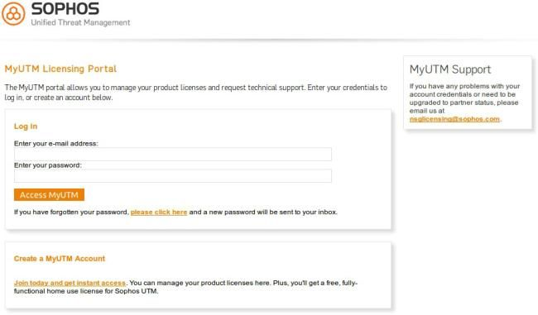
Fig - 5.1 Initial Setup Wizard — Licensing Screen
5.2 Interface & Zone Configuration
Building on the architecture defined in Chapter 4.3, interfaces were configured under the Network Interfaces module: physical ports were assigned static IP addresses, VLAN sub-interfaces were created and bound to their respective zones (LAN, DMZ, Management), and interface speed/duplex settings were left at auto-negotiate, appropriate for the lab's virtualized network adapters. Each interface's zone binding was cross-verified against the intended rule base of Chapter 6.1 before rule authoring began — a mis-bound interface silently defeats zone-based policy, and is, in practice, a common root cause of unintended traffic permits in production deployments.
5.3 IP Addressing Scheme
A hierarchical, non-overlapping addressing scheme was applied across zones using private (RFC 1918) address space, with each zone allocated a distinct subnet and the firewall holding the first usable host address in each as the default gateway.
Interface | Zone | IP Address | Subnet Mask
Port 1 (LAN 1) | Trust | 10.0.0.1 | /8 (255.0.0.0)
Port 2 (LAN 2) | Trust | 20.0.0.1 | /8 (255.0.0.0)
Port 3 (WAN Link) | Untrust | 192.168.1.1 | /30 (255.255.255.252)
Port 4 (DMZ) | DMZ | 172.16.0.1 | /24 (255.255.255.0)
Table -4.IP Addressing Scheme — Interface, Zone, IP, Subnet
Subnetting was deliberately kept broadcast-domain-aligned with zone boundaries — no zone spans multiple VLANs, and no VLAN spans multiple zones — to keep the source-IP-to-zone mapping unambiguous for the syslog-based correlation built in Chapter 11.1. Exact addressing detail is withheld in accordance with the confidentiality scope defined in Chapter 1.3; the scheme referenced throughout this report is a lab-representative, non-production layout.
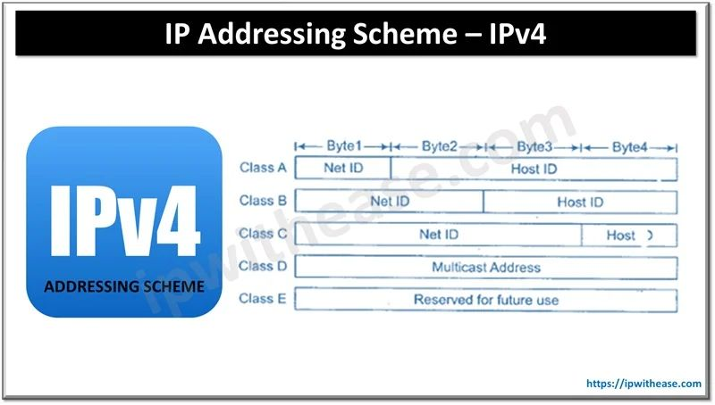
Fig - 5.2 IP Addressing Scheme Diagram

5.4 Routing / DNS / DHCP Configuration
Routing: static routes were configured for inter-zone and upstream traffic. SFOS additionally supports SD-WAN policy routing (application- or performance-based link selection across multiple WAN uplinks) and dynamic routing protocols — OSPF, BGP, and RIP — via its Dynamic Routing module. Neither was required at this deployment's scale, but both are relevant to production multi-site Sophos rollouts of the kind observed generally during the industrial exposure phase of this training.
DNS: the firewall was configured as the authoritative internal DNS forwarder, relaying upstream queries to public resolvers with request logging enabled — a log source of direct relevance to the detection pipeline built later in this report (Chapter 11.4), since the malicious-domain detection logic built as a Sigma rule mapped to MITRE ATT&CK technique T1071.004 (Chapter 11.4) depends specifically on this DNS query log being forwarded to the SIEM.
DHCP: SFOS was configured to act as the DHCP server for the LAN and DMZ segments, defining the address pool, lease duration, and default gateway/DNS options distributed to clients. DHCP relay — forwarding client requests to an existing upstream DHCP infrastructure — is the alternative configuration pattern, not required here since the lab firewall functioned as the sole DHCP authority.
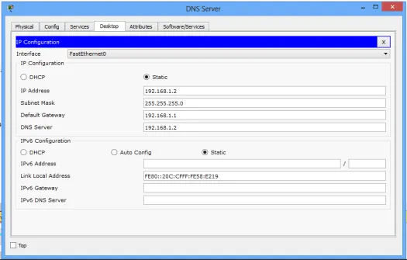
Fig- 5.3 DNS Configuration Screen
6. Security Policy Implementation
6.1 Firewall Rules & NAT
SFOS evaluates firewall rules top-down on a first-match basis, against an implicit default-deny at the base of the rule table — a design consistent with the least-privilege principle central to Zero Trust security models.
Incoming Packet
↓
Rule 1
↓
Rule 2
↓
… Rule N
↓
Default: Deny (no match)
Fig- 6.1 Firewall Rule Evaluation Order — First-Match, Default-Deny
Evaluation halts at the first rule whose zone, network, service, and (where applicable) user/group criteria are satisfied — no subsequent rule is checked once a match occurs, which is why rule ordering itself is a security-relevant design decision, not merely a cosmetic one: a broad permissive rule placed above a narrower restrictive rule silently defeats the restriction. Two rule categories exist: User/Network Rules, which are general-purpose and zone/network/service/user-based, and Business Application Rules, which are pre-templated for specific published services such as RDP or SSL VPN. Each rule additionally carries optional security-policy bindings — IPS policy, Application Control policy, Web policy, and antivirus scanning — meaning a single firewall rule functions as the enforcement point for several orthogonal controls simultaneously, rather than as a simple access-control-list entry.
NAT was implemented using SFOS's linked NAT model: outbound Internet-bound LAN traffic uses MASQ (dynamic Port Address Translation) against the WAN interface, while inbound access to a DMZ-hosted service uses a static Destination NAT rule (one-to-one, non-PAT) paired with an explicit permit rule. SFOS requires both the NAT rule and a corresponding firewall rule for post-NAT traffic to actually pass — a frequent point of misconfiguration for practitioners transitioning from platforms with unified NAT/rule logic.
Logging was enabled on every rule, not restricted to deny events. Allow-traffic logging was deliberately retained despite its higher log volume, since the detection pipeline built in Chapters 9 to 15 depends on permitted-traffic telemetry — for example, a successful authentication event over an allowed VPN rule (Chapter 12.1) — as much as it depends on denied-traffic telemetry.
Rule ID | Source Zone | Destination Zone | Service / Port | Action
101 | LAN | WAN | HTTP/HTTPS (80, 443) | Allow
102 | WAN | LAN | SSH (22) | Drop
103 | LAN | DMZ | DNS (53) | Allow
104 | Any | Any | Any | Deny (Default)
Table 5 - Sample Firewall Rule Base
6.2 User Authentication (AAA link)
This section directly implements the AAA framework established in Chapter 2.3. Authentication was configured through SFOS's Authentication Server integration: the lab environment used the local user database augmented with a demonstration Active Directory bind, using SFOS's Transparent Authentication Suite for clientless single sign-on via domain-controller login-event polling, as an alternative to the endpoint-resident authentication agent. Where transparent authentication is unavailable — for instance, on a non-domain device — a captive portal enforces an explicit browser-based login prompt before a firewall rule's user/group criteria can be matched.
Authorization is enforced at the rule level: firewall, web, and application rules reference Active Directory security groups directly, binding policy to identity rather than to static IP address — a necessity in DHCP-addressed environments where the IP-to-user mapping is not persistent across sessions. Accounting is satisfied by SFOS's authentication logs, which record login, logout, and authentication-failure events per user — the same event stream that the authentication-failure test scenario in Chapter 12.1 and its corresponding Wazuh detection rule in Chapter 11.2 are built to consume.
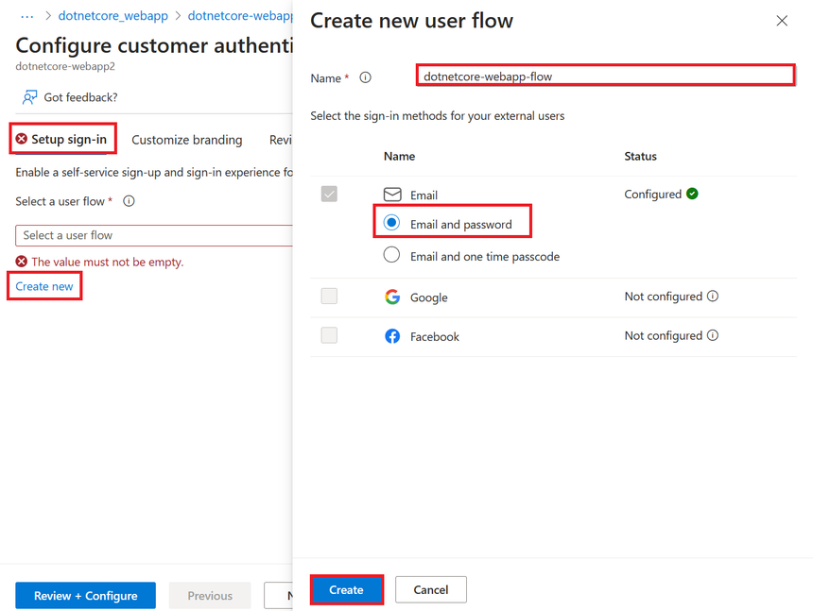
Fig - 6.2 User Authentication Setup
6.3 Application Control
Application Control operates through Layer 7 signature matching against Sophos's maintained application-signature database, organized both by category (for example, Proxy & Tunnel, File Transfer, Social Networking) and by individual application or micro-application function. Policies were authored to explicitly block high-risk categories — Proxy & Tunnel, commonly abused for policy evasion and command-and-control tunneling, and Peer-to-Peer — while permitting business-required categories, with QoS/traffic-shaping applied to bandwidth-intensive but legitimate categories such as streaming media rather than an outright block, illustrating policy authored for business enablement rather than blanket restriction.
Application-signature match events are logged with the identified application ID, a materially higher-fidelity data point than raw port/protocol observation for later correlation. Identifying, for example, a Tor or generic-anonymizer-proxy signature match constitutes a stronger indicator of compromise than a raw destination-port observation alone, and was treated as a candidate detection use case during the rule-design work described in Chapter 11.4.
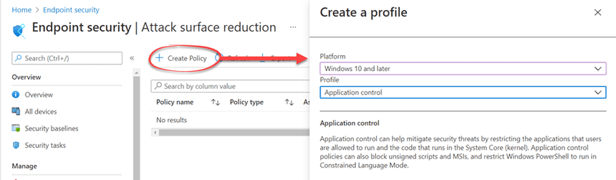
Fig – 6.3 Application Control Policy
6.4 Web Filtering & Website Blocking
Web filtering was implemented through category-based URL filtering against Sophos's cloud-maintained URL database, with policy bound per user/group using the same Active Directory authorization model established in Chapter 6.2. Category-level blocks were enforced for Malware/Phishing sites, blocked outright regardless of policy tier, and for Adult/Gambling categories, blocked in line with an acceptable-use policy, alongside SafeSearch enforcement on major search engines. HTTPS URL filtering requires SSL inspection (Chapter 6.5) to be active for full-path visibility; absent decryption, category matching on HTTPS traffic is limited to the TLS Server Name Indication and certificate common-name fields rather than the full URL path.
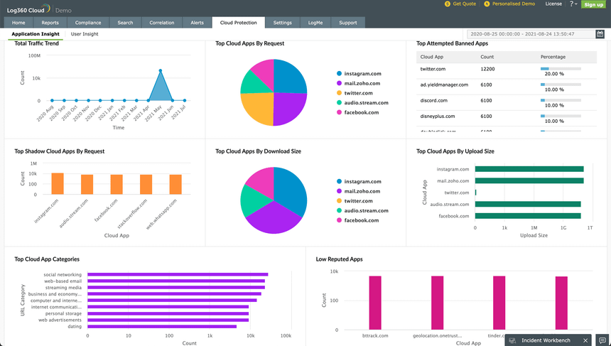
Fig – 6.4 Web Filtering
6.5 IPS & SSL Inspection
The IPS engine — a Snort-derived signature ruleset, updated continuously via Sophos's threat-intelligence feed — was bound to the relevant firewall rules through IPS policy attachment. Policies were tuned per zone rather than applied uniformly: a stricter policy was bound to WAN-facing and DMZ rules, while a relaxed policy was applied to internal LAN-to-LAN rules to reduce false-positive volume on inherently trusted traffic.
This tuning decision has a direct bearing on SOC alert fidelity — an over-broad IPS policy applied indiscriminately to low-risk internal segments is a recognized contributor to alert fatigue in production SOC environments.
SSL inspection was configured in decrypt-and-inspect mode, requiring deployment of the SFOS-generated CA certificate to lab endpoint trust stores to avoid client-side certificate-warning or certificate-pinning failures. An explicit decrypt-bypass list was maintained for categories where inspection is inappropriate or technically infeasible — certificate-pinned applications, and banking-category sites, consistent with common compliance posture.
This decrypt boundary is a direct architectural constraint on the detection coverage of the SOC pipeline built in Chapters 9 to 15: any malicious payload transiting a bypassed TLS session is invisible to both the firewall's DPI engine and, by extension, to any syslog-derived Wazuh detection depending on that inspection — a limitation explicitly revisited in Chapter 14.3.
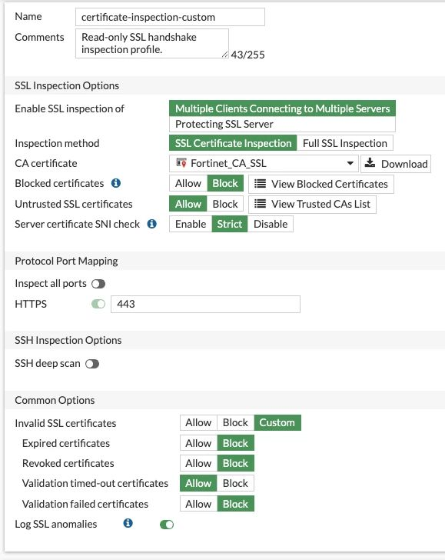
Fig - 6.5 IPS & SSL Inspection Configuration
6.6 Antivirus Protection
Gateway antivirus scanning was enabled on relevant protocols — HTTP/HTTPS, FTP, and SMTP/POP3 where applicable — using SFOS's flow-based single-engine scanning mode, an appropriate throughput/detection trade-off for this deployment's scale. Proxy-based dual-engine scanning, which offers greater detection depth at a latency cost, was evaluated conceptually but not adopted, given the lab's throughput profile.
Detected-and-blocked events are logged with the matched signature or threat name, the file hash where computed, and the source/destination endpoints involved. These fields are later cross-referenced against the MISP-integrated indicator-of-compromise enrichment workflow described in Chapter 11.5, illustrating the direct lineage from the gateway-level control configured in this chapter to the threat-intelligence correlation layer built in Chapter 11.5.
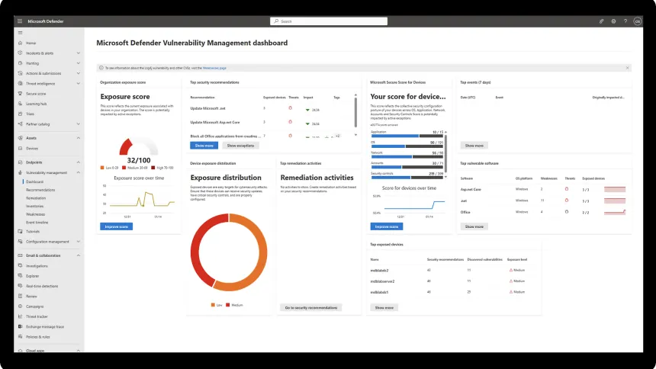
Fig - 6.6 Antivirus Protection Screen
7. VPN Implementation
7.1 Site-to-Site VPN
Site-to-Site VPN connectivity was implemented using IPsec (IKEv2) between two SFOS endpoints, simulating a branch-to-headquarters connectivity model of the kind observed during the industrial exposure phase. Tunnel negotiation follows the standard two-phase IKE exchange: Phase 1 (Main Mode) establishes a secure, authenticated channel between the two peers via Diffie-Hellman key exchange, over which Phase 2 (Quick Mode) negotiates the actual IPsec Security Association used to encrypt traffic. Pre-shared key (PSK) authentication was used for peer authentication in the lab, with X.509 certificate-based authentication noted as the stronger alternative typical of production deployments. The negotiated cryptographic profile used AES-256 for encryption and SHA-256 for integrity, with Diffie-Hellman Group 14 and Perfect Forward Secrecy (PFS) enabled on Phase 2 to ensure that compromise of a long-term key does not retroactively expose previously captured traffic.
SFOS supports both route-based VPN, which exposes the tunnel as a virtual XFRM interface and allows dynamic or static routing to determine which traffic enters it, and policy-based VPN, where the Security Association is bound directly to a defined set of traffic selectors (source/destination subnets). Route-based configuration was used in this training for its flexibility in supporting future topology changes without renegotiating traffic selectors. NAT-Traversal (NAT-T, encapsulating ESP within UDP 4500) was enabled to accommodate peers situated behind NAT, and Dead Peer Detection (DPD) was configured to monitor tunnel liveness and trigger re-negotiation on peer failure.
From a monitoring standpoint, Phase 1/Phase 2 negotiation success and failure events, along with tunnel up/down state transitions, are logged by SFOS and constitute operationally significant signal in their own right — a repeatedly flapping tunnel is as worthy of SOC investigation as an outright denial event, since it may indicate a misconfiguration, an MTU/fragmentation issue, or an active interference attempt on the WAN path.

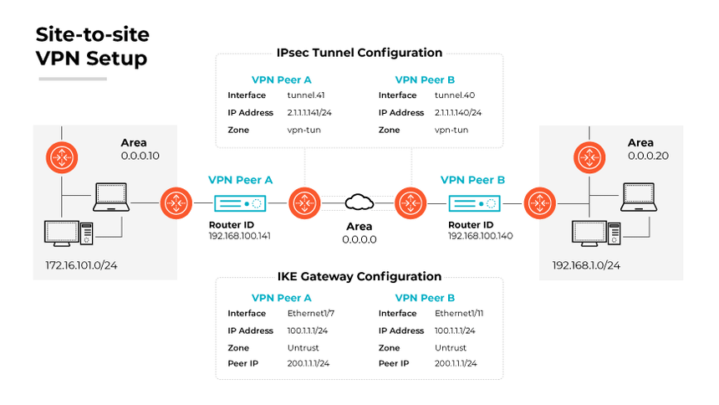
Fig - 7.1 Site-to-Site VPN Topology
7.2 Remote Access VPN
Two Remote Access VPN mechanisms were evaluated on the SFOS platform. SSL VPN operates over standard TLS, accessible either via the Sophos Connect client or a clientless web portal, and traverses restrictive firewalls/NAT more reliably than IPsec due to its use of standard HTTPS ports. IPsec-based remote access uses a dedicated client and the same IKEv2 negotiation model described in Chapter 7.1, adapted for a single-host peer rather than a site-to-site gateway pair.
Split-tunnel policy was configured for the lab deployment — routing only traffic destined for internal lab subnets through the tunnel, with general Internet-bound traffic exiting via the client's local connection — as opposed to full-tunnel policy, which routes all client traffic through the firewall and is typically preferred in higher-security postures despite the added inspection load. Remote users are assigned a virtual IP from a dedicated lease pool bound to the VPN zone (Chapter 4.3), and authentication is bound directly to the AAA framework configured in Chapter 6.2, with one-time password (OTP) token integration available as a second factor.
Remote Access VPN login events — source IP, authentication outcome, and assigned virtual IP — are a primary log source for this report's detection pipeline, feeding directly into the VPN-login test scenario documented in Chapter 12.1. A natural extension of this telemetry, noted here but not implemented within the scope of this project, is geolocation-based anomaly detection on the source IP of VPN logins (an “impossible travel” detection use case) — revisited as a limitation and future-scope item in Chapter 14.3.

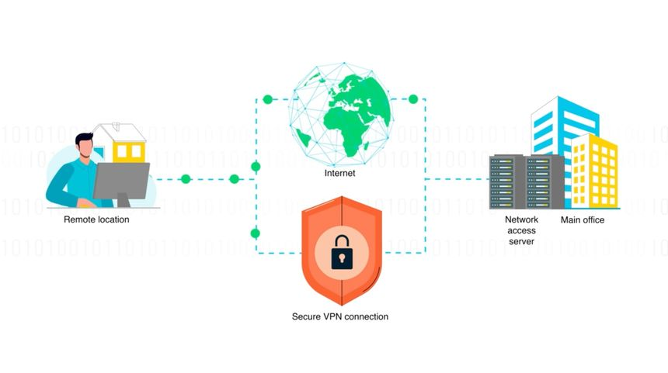
Fig – 7.2 Remote Access VPN Topology

Feature | Site-to-Site VPN | Remote Access VPN
Primary Use Case | Connects two entire branch offices | Connects one remote user to the office
Setup Location | Configured directly on the routers | Requires a client app on a laptop
User Effort | Invisible to the end user | User must manually log in
Table - 6. VPN Comparison — Site-to-Site vs Remote Access
8. Monitoring, Logging & Backup
8.1 Dashboard, Logs, Reports
The SFOS Control Center dashboard provides real-time operational visibility through widgets covering traffic summary, top applications by bandwidth, threat summary, IPS hit counts, and VPN tunnel status — serving as the first-line monitoring surface for day-to-day firewall administration. Beneath the dashboard, the Log Viewer streams real-time events segmented by log type: Firewall, IPS, Antivirus, Web, Application Control, Authentication, and System — each corresponding directly to the policy modules configured in Chapter 6. The Reports module supports scheduled report generation in PDF/CSV format for periodic review and audit purposes, distinct from the live Log Viewer stream.
Of direct relevance to the project documented later in this report, SFOS supports external syslog forwarding, configured under the Logs & Reports section, which exports the same event stream visible in the Log Viewer to a remote log collector over UDP or TCP port 514, or over TLS-encrypted syslog on port 6514 for confidentiality-sensitive deployments. Sophos structures forwarded messages as key-value pairs (for example, device=SFW… log_type=… log_component=…), a format that directly determines how the receiving system must be configured to parse it. This chapter documents the baseline syslog-export configuration performed within the Sophos console itself; the corresponding receiving-side configuration — including the custom Wazuh decoder written to parse this exact key-value format — is documented separately in Chapter 11.1, marking the precise technical handoff point between the firewall-administration chapters and the SOC project chapters of this report.
8.2 Backup & Restore
Scheduled configuration backups were configured under the Backup & Firmware section, with delivery options including local download, FTP push, and email-based delivery. Backups capture the complete firewall configuration and support password-based encryption to protect exported configuration data at rest — a relevant control given that a configuration backup, if exposed, reveals the full rule base, VPN parameters, and authentication server bindings of the deployment. The Firmware Management module additionally retains prior firmware versions to support rollback in the event a version upgrade introduces instability.
Backup and restore capability exists specifically to satisfy the Availability leg of the CIA Triad introduced in Chapter 2.1: in the event of appliance failure or misconfiguration, a recent backup materially reduces Recovery Time Objective (RTO), while a defined backup schedule bounds Recovery Point Objective (RPO) — the maximum acceptable configuration/data loss window. As operational practice during this training, dated configuration exports were taken before and after each significant policy change, functioning as a lightweight form of configuration version control and enabling rapid rollback if a change had an unintended effect on the rule base.

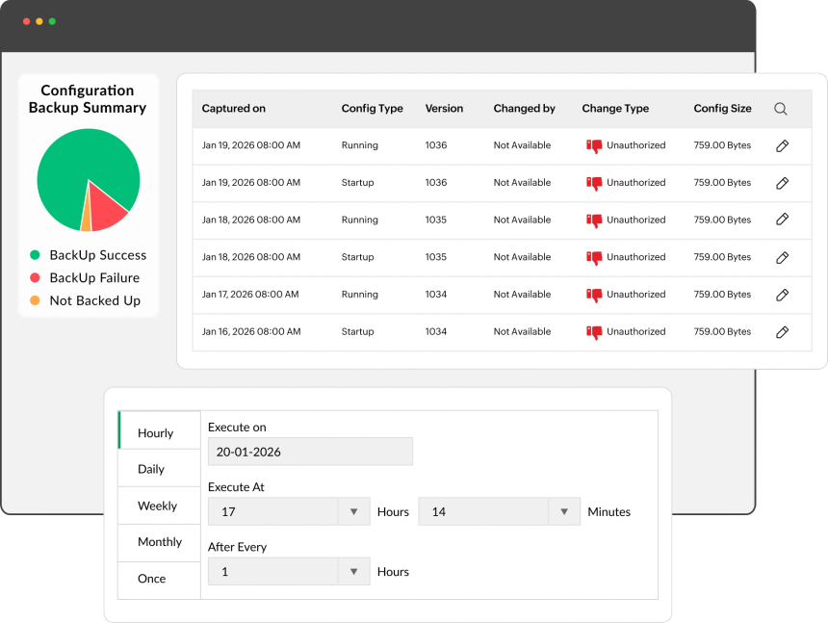 Fig- 8.2 Backup & Restore Configuration
9. Project Introduction
9.1 Motivation
As part of the B.Tech (Computer Science Engineering — Cyber Security) curriculum, and in conjunction with the industrial training in Sophos Firewall Configuration and Network Security documented in Chapters 1 to 8 of this report, a self-directed practical project was undertaken to design, deploy, and document a functional Security Operations Center (SOC) environment. The project integrates endpoint security monitoring, network perimeter defence, and threat intelligence correlation into a single, cohesive detection pipeline, implemented and validated within an isolated laboratory environment.
Tool Name | Purpose | Version
Sophos XG | Next-Generation Firewall for traffic filtering | SFOS v18.5
Kali Linux | Offensive testing and vulnerability scanning | 2025.4
VMware Workstation | Running virtual lab environments | 17 Pro
Wireshark | Capturing and analysing network packets | 4.2.0
Table - 7. Tools Used in Project — Tool, Purpose, Version
This project directly reinforces and extends the practical skills acquired during the industrial training. While the training provided exposure to enterprise firewall administration in a live operational context (Chapters 4 to 8), it did not, by design, extend into detection engineering, SIEM deployment, or threat intelligence integration — a boundary explicitly noted in the scope statement of Chapter 1.3. This project supplies a complementary, self-directed environment in which that firewall knowledge is integrated into a broader security-monitoring and detection-engineering workflow, connecting perimeter security configuration to SIEM-based detection and threat intelligence — a linkage not always visible when firewall administration is performed in isolation, and one that mirrors the structure of a production SOC, where perimeter, endpoint, and intelligence functions are typically owned by separate but interdependent teams.
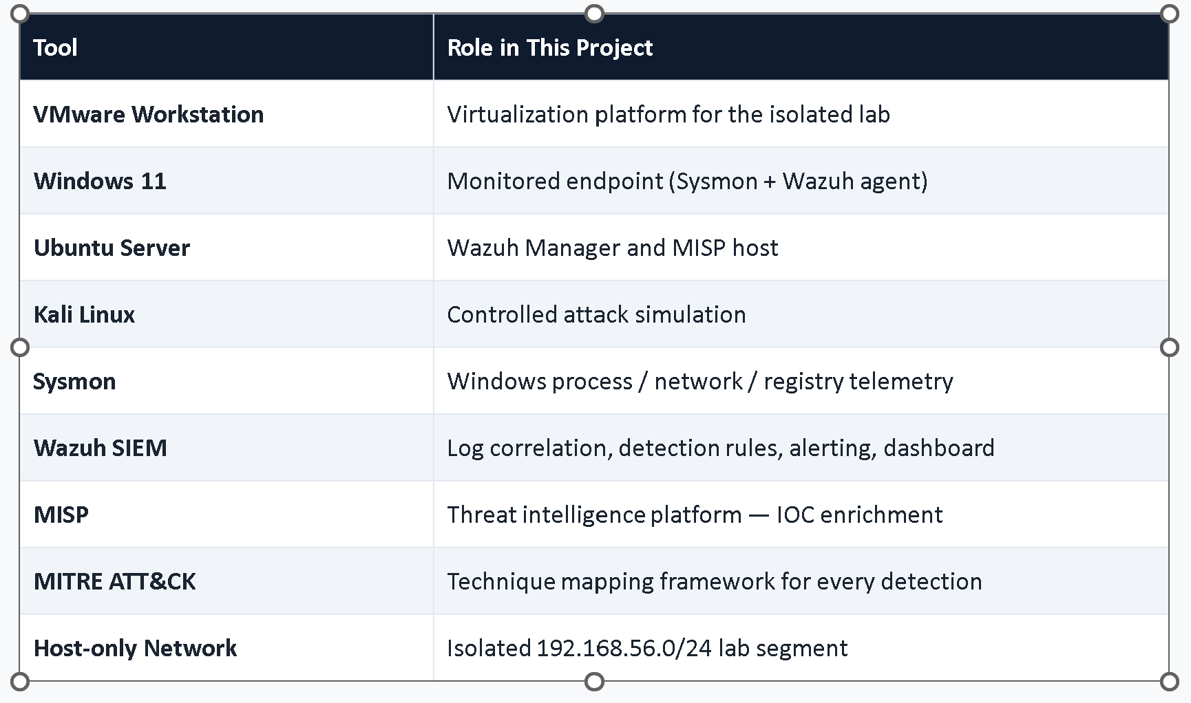
Fig 9.1 – Tool Stack
9.2 Objective & Scope
The objective of this project is to gain hands-on, verifiable experience with the core technologies and workflows used in a production-grade Security Operations Center. Specifically:
- To deploy and configure a Security Information and Event Management (SIEM) platform (Wazuh) for centralized log collection, correlation, and alerting.
- To integrate the Sophos Firewall documented in Chapters 4 to 8 as the network perimeter layer, configuring syslog-based log forwarding to the SIEM, building directly on the baseline established in Chapter 8.1.
- To author custom detection logic — Sigma rules and Wazuh-native rules — mapped to the MITRE ATT&CK framework.
- To integrate a threat intelligence platform (MISP) for automated indicator-of-compromise (IOC) enrichment of generated alerts.
- To validate the complete detection pipeline through controlled adversarial simulation and structured incident investigation.
The scope of the project covers the complete lifecycle of a SOC detection pipeline: endpoint telemetry collection using Sysmon (Windows) and Auditd (Linux); perimeter telemetry collection via Sophos Firewall syslog export; centralized correlation and rule-based detection in Wazuh; threat intelligence enrichment via MISP; attack simulation using industry-standard tooling; and structured incident investigation and response documentation. The entire environment was implemented within an isolated, host-only virtual network to ensure containment of simulated adversarial activity, consistent with responsible security-testing practice — no production or client infrastructure was used at any stage, in line with the confidentiality obligations stated in Chapter 1.3.
The four threat scenarios selected for validation in Chapter 12 were not chosen arbitrarily; they were derived from a brief threat-modelling exercise against the lab environment defined in Chapter 10.2, prioritizing the threats most directly relevant to the assets and log sources actually instrumented:
Threat Scenario | Primary Asset at Risk | Likelihood (lab context) | Impact | Mapped MITRE Technique
Credential brute-force against firewall/VPN portal | Authentication service, VPN access | High — externally reachable service | High — successful compromise grants network access | T1110
Malware call-back via malicious DNS resolution | Endpoint, internal network integrity | Medium — requires prior endpoint compromise | High — indicates active C2 channel | T1071.004
Encoded PowerShell execution (defense evasion) | Endpoint integrity | Medium — common post-exploitation step | High — often precedes further compromise | T1059.001
Unauthorized VPN access using valid credentials | VPN gateway, internal network | Low–Medium — depends on credential exposure elsewhere | High — bypasses perimeter entirely if successful | T1078 (Valid Accounts, related)
Table –8. Risk Matrix
This prioritization — favouring threats with both plausible likelihood in the lab's threat surface and high potential impact — is the basis on which the specific rule set in Chapter 11 and the specific test scenarios in Chapter 12 were chosen, rather than an arbitrary or exhaustive attempt to cover the entire ATT&CK matrix within this project's scope.
9.3 Tools Used
The following tools and technologies were used across the project, grouped by functional category. For SIEM and log correlation, Wazuh was deployed as the primary platform. Wazuh's current architecture (v4.x) comprises the Wazuh Manager (rule engine and log processing), the Wazuh Indexer — a fork of OpenSearch, itself derived from Elasticsearch — handling storage and search, and the Wazuh Dashboard, built on OpenSearch Dashboards, for visualization; this report uses the current Indexer/Dashboard terminology throughout rather than the legacy Elasticsearch/Kibana naming associated with older Wazuh releases, to accurately reflect the deployed stack. Perimeter security telemetry originates from the Sophos Firewall (SFOS) configured in Chapters 4 to 8. Endpoint telemetry was collected using Sysmon and native Windows Event Logs on Windows hosts, and Auditd on Linux hosts.
Threat intelligence was sourced from a self-hosted MISP instance, enriched with open community feeds — abuse.ch's URLhaus (malicious URL feed) and ThreatFox (IOC feed). Detection engineering was performed using the Sigma generic rule format, cross-referenced against the MITRE ATT&CK framework for technique mapping. Attack simulation used Nmap for network reconnaissance, Hydra for credential brute-force simulation, Netcat for basic connection and exfiltration-pattern simulation, and the Atomic Red Team framework for scripted, MITRE-technique-mapped adversary emulation. The environment was virtualized using VirtualBox on an isolated host-only network, running a mix of Windows 10/11, Ubuntu Server, and Kali Linux.
The following table summarizes the scale of the deployed lab environment and the resulting output of the detection-engineering effort, providing a measurable baseline for the results discussed in Chapter 12:

Metric | Value
Virtual machines deployed | 6 (Wazuh Manager/Indexer/Dashboard, MISP, Windows endpoint, Linux endpoint, Kali attacker, Sophos SFOS)
Total allocated RAM (lab) | ~20 GB across all VMs
Total allocated vCPU (lab) | 12 vCPU across all VMs
Custom Wazuh decoders authored | 3 (Chapter 11.2)
Custom Wazuh / Sigma detection rules authored | 6, spanning authentication, DNS, and endpoint process-execution detections
MITRE ATT&CK techniques covered | 4 (T1110, T1071.004, T1059.001, and one endpoint persistence technique)
Threat-intelligence feeds integrated | 2 (URLhaus, ThreatFox) via MISP
Test scenarios executed | 4 (Chapter 12.1), each run multiple times for consistency

Table –9. Security Information and Event Management Lab Specifications
10. Project Architecture
10.1 System Diagram (Sophos → Wazuh → MISP)
The pipeline is best understood as a directed data-flow. The Sophos Firewall configured in Chapters 4 to 8 exports its Firewall, IPS, Authentication, and Antivirus log streams as syslog, over UDP port 514, to a dedicated log-collection host running an rsyslog listener, which writes the received stream to a flat file for ingestion.
The Wazuh Manager, running on the same log-collection host, monitors this file via a localfile block and applies the custom decoder and rule set documented in Chapter 11.1–11.2 to parse and classify each event. In parallel, the Windows and Linux endpoint hosts each run a Wazuh agent, which forwards Sysmon (Windows) and Auditd (Linux) telemetry to the same manager over the Wazuh agent protocol — an encrypted, authenticated channel on TCP port 1514.
Sophos Firewall
↓
rsyslog (UDP 514)
↓
Wazuh Manager
↓
Wazuh Indexer
↓
Wazuh Dashboard
Fig 10.1 System Architecture — Sophos → Wazuh → MISP Data Flow
Once an event is decoded and matched against a rule, the Wazuh Manager writes the resulting alert to the Wazuh Indexer for storage and search, made visible through the Wazuh Dashboard. Where a rule match involves an extractable indicator — a destination IP, domain, or file hash — the Wazuh integrator daemon (wazuh-integratord) triggers a custom integration script that queries the MISP REST API over HTTPS to check the indicator against locally stored threat-intelligence attributes, appending any match as enrichment to the original alert before it reaches the analyst.
This Sophos → Wazuh → MISP flow is therefore not three independent tools but a single pipeline with five distinct stages, summarized below and referenced throughout Chapter 11:
1. Collect (Sophos syslog, Sysmon, Auditd)
↓
2. Decode (custom Wazuh decoder)
↓
3. Detect (Wazuh / Sigma rule match)
↓
4. Enrich (MISP IOC lookup)
↓
5. Alert & Investigate (Wazuh Dashboard)
Fig 10.2 Detection Lifecycle — Collection Through Alert & Investigation
10.2 Network / IP Design
The lab was built entirely within an isolated, host-only VirtualBox network to guarantee containment of simulated adversarial traffic. Three logical subnets were used: a Management subnet (10.10.10.0/24) hosting the Wazuh Manager/Indexer/Dashboard stack and the MISP instance; a Monitored subnet (10.10.20.0/24) hosting the Windows 10/11 and Ubuntu Server endpoints instrumented with Sysmon/Auditd and the Wazuh agent; and an Attacker position occupied by a Kali Linux host, placed on the Monitored subnet to realistically traverse the same perimeter and detection surface as a genuine external or lateral-movement actor. The Sophos Firewall, retained from the earlier deployment (Chapters 4 to 8), was positioned as the gateway between the simulated WAN segment and the Monitored subnet.
Simulated WAN
↓
Sophos Firewall (Gateway)
↓
Monitored Subnet — 10.10.20.0/24
↓
Management Subnet — 10.10.10.0/24
Fig10.3 Lab Network Topology — Zone and Subnet Layout
This layout ensures that perimeter telemetry (Chapter 8.1) and endpoint telemetry (Chapter 11.3) both cover the same traffic paths exercised during testing (Chapter 12), so that a simulated attack traversing the Sophos gateway is visible from both the firewall's and the endpoint's perspective simultaneously — the same dual-visibility principle underlying the Defense-in-Depth model introduced in Chapter 2.4.
10.3 Component Roles & Justification
Wazuh was selected as the central SIEM/XDR platform for its open-source licensing model, its dual agent-based and agentless collection capability, its built-in ruleset with native MITRE ATT&CK tagging support, and its active-response framework — collectively offering a feature set comparable to commercial platforms without licensing cost, an appropriate fit for an academic project. The underlying Wazuh Indexer and Dashboard (OpenSearch-based, per Chapter 9.3) provide the storage, search, and visualization layer Wazuh is built on.
This choice was not made in isolation; the table below summarizes how Wazuh compares against the commercial and alternative open-source platforms most commonly deployed in production SOC environments, on the criteria most relevant to this project:
Platform | License Model | Detection-as-Code Support | Relevant Trade-off
Wazuh (used) | Open-source (free) | Native XML rules; Sigma portable via manual/backend conversion | No cost, full configuration control; smaller out-of-box content library than commercial platforms
Splunk Enterprise Security | Commercial, volume-based licensing | SPL-based correlation searches; Sigma backend available | Very strong ecosystem and support; licensing cost scales with log volume, impractical for a student lab
IBM QRadar | Commercial, EPS-based licensing | AQL-based rules | Strong compliance/enterprise tooling; high infrastructure and licensing overhead
Microsoft Sentinel | Commercial, cloud-consumption based | KQL-based analytics rules; native Sigma-to-KQL conversion | Tight Azure/M365 integration; requires an Azure tenant and incurs cloud cost
Elastic Security | Open-core (free tier + paid features) | Detection rules on Elastic Query DSL/EQL; native Sigma import | Strong search performance; advanced detection features gated behind paid tiers
Table -10. Tool Stack with Model

Wazuh was judged the best fit specifically because it required no licensing cost, could be fully self-hosted within the isolated lab described in Chapter 10.2, and — critically for a detection-engineering-focused project — exposes its full rule and decoder logic as editable, version-controllable XML rather than as opaque managed-service configuration.
MISP was selected as the threat-intelligence platform for its open-source availability, REST API-driven automation, and native compatibility with community threat feeds in both MISP and STIX/TAXII formats, enabling the IOC-enrichment workflow described in Chapter 11.5.
Sysmon was chosen for Windows endpoint telemetry specifically because it exposes process-creation command lines, network-connection events, and image/DLL load events that are absent from default Windows Event Logging — the level of granularity required for meaningful detection-rule authoring. Auditd serves the equivalent role on Linux, providing syscall-level auditing.
Component | Role in Network | Justification
Core Router | Routes traffic between distinct subnets | Essential for inter-VLAN routing
NGFW Appliance | Inspects payloads and enforces policies | Protects against Layer 7 attacks
Managed Switch | Connects end devices via Ethernet | Enables physical and VLAN segmentation
Table - 11. Component Roles & Justification
Sigma was adopted as the detection-rule authoring format specifically for its vendor-agnostic, detection-as-code design, allowing rule logic to be documented independently of the specific SIEM backend it is ultimately deployed against — aligned with prevailing community detection-engineering practice (Chapter 11.4 discusses this choice further against the alternative of authoring rules directly in YARA). Kali Linux, Atomic Red Team, Nmap, and Hydra were used for attack simulation specifically because each supports controlled, repeatable, and MITRE-technique-mapped testing, in preference to unstructured manual testing that would not map cleanly to the detection logic being validated.
11. Implementation
11.1 Sophos Syslog Configuration
Building directly on the baseline established in Chapter 8.1, the Sophos Firewall's external syslog target was set to the log-collection host's management-subnet address on UDP port 514, with logging scope covering the Firewall, IPS, Authentication, and Antivirus modules. Because Wazuh does not natively listen on the syslog port, an rsyslog instance on the receiving host accepts the UDP stream and writes it to a dedicated log file, which the Wazuh manager then monitors as a localfile source:
<localfile>
<log_format>syslog</log_format>
<location>/var/log/sophos/firewall.log</location>
</localfile>
This two-stage collection pattern (rsyslog receive → file write → Wazuh tail) was adopted over a direct syslog listener on the Wazuh manager itself, as it decouples raw log receipt from parsing, allowing the raw file to be retained independently for audit purposes even if the decoder pipeline is later modified.
11.2 Wazuh Decoder & Rule Authoring
Sophos structures its syslog output as space-delimited key-value pairs (for example, device=SFW… log_type=Firewall… status=Deny…), a format not covered by Wazuh's default decoder set. A custom decoder was therefore authored to parse this structure into discrete, queryable fields:
<decoder name="sophos-firewall">
<program_name>^SFW</program_name>
</decoder>

<decoder name="sophos-firewall-kv">
<parent>sophos-firewall</parent>
<prematch>log_type=Firewall</prematch>
<regex offset="after_prematch">log_component=(\S+) log_subtype=(\S+) status=(\S+)</regex>
<order>log_component, log_subtype, status</order>
</decoder>

<decoder name="sophos-firewall-fields">
<parent>sophos-firewall</parent>
<regex>src_ip=(\S+) dst_ip=(\S+) src_port=(\d+) dst_port=(\d+) srczone=(\S+) dstzone=(\S+)</regex>
<order>srcip, dstip, srcport, dstport, extra_data, extra_data</order>
</decoder>
With decoding in place, detection rules were authored against the resulting fields. Wazuh's rule syntax supports rule chaining via if_sid, field-level matching, a 0–16 severity scale, and native MITRE ATT&CK tagging — used directly to bind each rule to the technique it detects. The following rule pair establishes a baseline decoded-event rule and a specific authentication-failure detection built on top of it:
<group name="sophos,firewall,">
<rule id="100010" level="0">
<decoded_as>sophos-firewall</decoded_as>
<description>Sophos Firewall generic event.</description>
</rule>

<rule id="100011" level="8">
<if_sid>100010</if_sid>
<field name="status">Deny</field>
<field name="log_subtype">Authentication</field>
<description>Sophos Firewall: authentication failure detected.</description>
<mitre>
<id>T1110</id>
</mitre>
<group>authentication_failed,</group>
</rule>
</group>
Rule 100010 is deliberately assigned level 0 (no alert generated) and serves purely as a decoding checkpoint; rule 100011 inherits from it via if_sid and adds the field-level conditions that define an actual detection, illustrating Wazuh's rule-inheritance model, in which specificity and severity increase as rules build on one another.
11.3 Endpoint Telemetry (Sysmon + Wazuh Agent)
On Windows endpoints, Sysmon was deployed using a modular, community-maintained configuration (in the style of the SwiftOnSecurity/Olaf Hartong baselines) to enable process-creation logging (Event ID 1, capturing full command lines and parent-process lineage), network-connection logging (Event ID 3), and image/DLL load logging (Event ID 7) — the specific telemetry classes required by the Sigma rules authored in Chapter 11.4. The Wazuh agent was configured to read the Sysmon operational channel directly:
<localfile>
<log_format>eventchannel</log_format>
<location>Microsoft-Windows-Sysmon/Operational</location>
</localfile>
On Linux endpoints, equivalent telemetry depth was achieved through Auditd, with rules watching identity-critical files and system-call activity relevant to privilege and persistence techniques:
auditctl -w /etc/passwd -p wa -k identity
auditctl -w /etc/shadow -p wa -k identity
auditctl -a always,exit -F arch=b64 -S execve -k exec_commands
The Wazuh agent on Linux hosts was configured to monitor /var/log/audit/audit.log using the audit log format, feeding the same manager-side decoder and rule pipeline as the Windows telemetry stream.
11.4 Sigma Rules mapped to MITRE ATT&CK
The MITRE ATT&CK framework used throughout this report for technique tagging is structured as a strict hierarchy, illustrated below, and it is this hierarchy — not just the technique ID itself — that gives a tag like T1059.001 its analytical meaning: it identifies not only what happened, but which broader adversary goal (tactic) it served.
Enterprise ATT&CK Matrix
↓
Tactic (e.g., Execution)
↓
Technique (e.g., T1059 — Command & Scripting Interpreter)
↓
Sub-technique (e.g., T1059.001 — PowerShell)
Figure 11.5 MITRE ATT&CK Hierarchy — Matrix, Tactic, Technique, Sub-technique
Detection logic for endpoint-derived telemetry was authored in the vendor-agnostic Sigma format before being ported to native Wazuh rules, preserving a clean, portable specification of detection intent independent of the backend it is ultimately deployed against.
Sigma, rather than YARA, was chosen as the authoring format for this layer of detection logic because the two formats solve different problems: YARA matches byte-level and string patterns within a file or memory region, and is the standard for identifying known malware samples; Sigma matches structured field-value conditions within a log event, and is the standard for identifying suspicious behaviour in log/telemetry streams — which is precisely the input this project's pipeline produces (Sysmon and Sophos syslog events, not raw files). Since no malware-sample scanning was performed in this project's scope, and all detection logic operates on structured log fields, Sigma is the format-appropriate choice; YARA would be the correct choice for a file/memory-scanning use case, which this project does not include.
The following Sigma rule detects a common defense-evasion pattern — Base64-encoded PowerShell command execution — mapped to MITRE ATT&CK technique T1059.001 (Command and Scripting Interpreter: PowerShell):
title: Suspicious Encoded PowerShell Command
status: experimental
logsource:
product: windows
category: process_creation
detection:
selection:
Image|endswith: '\\powershell.exe'
CommandLine|contains: '-enc'
condition: selection
level: high
tags:
- attack.execution
- attack.t1059.001
This rule was ported to a native Wazuh detection rule matching on the equivalent Sysmon Event ID 1 fields (win.eventdata.image and win.eventdata.commandLine), with the MITRE tag preserved directly in the Wazuh rule definition — ensuring that the technique mapping established at the Sigma-authoring stage is not lost in translation and remains queryable in the Wazuh dashboard for ATT&CK-based alert triage.
The complete set of MITRE ATT&CK techniques covered by the detection rules authored across this project is summarized below, providing the coverage baseline referenced in the project metrics of Chapter 9.3:
Tactic | Technique ID | Technique Name | Detection Rule
Credential Access | T1110 | Brute Force | Wazuh rule 100011 (Chapter 11.2), Sophos authentication-failure log
Command & Control | T1071.004 | Application Layer Protocol: DNS | Sigma/Wazuh DNS rule, Sophos DNS query log (Chapter 5.4)
Execution | T1059.001 | Command and Scripting Interpreter: PowerShell | Sigma rule above, ported to Wazuh (this section)
Persistence | T1547 (subset) | Boot or Logon Autostart Execution | Auditd-derived Wazuh rule on identity-file/registry-equivalent watch (Chapter 11.3)
Table -12. Sigma Rule to MITRE ATT&CK Mapping
11.5 MISP Threat Intel Integration
Before describing the integration itself, it is useful to define how MISP structures the threat intelligence it stores, since the enrichment workflow below depends directly on this data model. An Event in MISP represents a single threat or incident context (for example, a specific malware campaign); each Event contains one or more Attributes, the individual indicators of compromise themselves (an IP address, domain, or file hash); related Attributes may be grouped into an Object (for example, a file object bundling a filename, hash, and size together); Galaxies attach higher-level context to an Event, such as a named threat-actor or malware-family cluster; and Taxonomies apply standardized classification tags (for example, confidence level or traffic-light-protocol sharing classification) across Events and Attributes. The integration described below queries specifically at the Attribute level — matching a single extracted indicator against MISP's Attribute database — and surfaces any associated Event, Galaxy, and Taxonomy context as enrichment.
Automated indicator-of-compromise enrichment was implemented via a custom Wazuh integration script, invoked by wazuh-integratord whenever a rule carrying an extractable indicator (destination IP, domain, or file hash) fires. The script queries the MISP REST API's restSearch endpoint using an authenticated API key; where the indicator matches an existing MISP attribute, the corresponding event ID, associated tags, and threat-actor attribution (where present in the feed) are appended to the original Wazuh alert as enrichment data before the analyst sees it. The integration was registered in the manager configuration as follows:
<integration>
<name>custom-misp</name>
<hook_url>https://misp.lab.local/attributes/restSearch</hook_url>
<api_key>API_KEY_PLACEHOLDER</api_key>
<rule_id>100011,100020</rule_id>
<alert_format>json</alert_format>
</integration>
This design deliberately scopes enrichment to a specific rule_id list rather than applying it to every alert — unrestricted enrichment against every event would generate excessive MISP API load and enrichment noise on alerts (such as informational log entries) where an IOC lookup adds no analytical value.
12. Testing & Results
12.1 Test Scenarios (auth fail, VPN login, malicious DNS, negative control)
Each scenario below was evaluated using a consistent, five-stage investigative workflow adapted from the standard NIST incident-response lifecycle, ensuring that every test was assessed the same way rather than informally:
1. Preparation
↓
2. Detection
↓
3. Analysis
↓
4. Validation
↓
5. Documentation
Fig 12.1 Test Evaluation Workflow (adapted from NIST SP 800-61 Incident Response Lifecycle)
Four controlled test scenarios were designed to validate the detection pipeline end-to-end using this workflow, each mapped to a specific stage of the architecture described in Chapter 10 and a specific rule or rule set described in Chapter 11.
- Authentication failure: a scripted brute-force attempt was run from the Kali host against the Sophos authentication portal using Hydra, generating repeated authentication-failure events. Expected outcome: Wazuh rule 100011 (Chapter 11.2) firing with MITRE technique T1110 (Brute Force) tagged against the resulting alert.
- VPN login: a Remote Access VPN connection was established from the Kali host, simulating an external actor authenticating successfully. Expected outcome: a logged VPN-login event captured via the Sophos syslog pipeline, including source IP and assigned virtual IP, validating that legitimate authenticated activity — not only denied traffic — is visible to the SIEM, consistent with the allow-traffic logging rationale established in Chapter 6.1.
- Malicious DNS resolution: an endpoint was made to resolve a domain corresponding to a known-malicious indicator sourced from the ThreatFox feed, exercising the DNS-based Sigma detection referenced in Chapter 5.4 (MITRE T1071.004). Expected outcome: a Wazuh alert generated from the DNS query log, subsequently enriched with a positive MISP match confirming the domain's known-bad classification.
- Negative control: benign, everyday traffic — legitimate web browsing and a successful, correctly-credentialed login — was generated and confirmed not to trigger any of the above detection rules, validating rule specificity and providing a baseline false-positive check against normal operational traffic.
12.2 Screenshots & Evidence
Evidence for each scenario in Section 12.1 — Sophos log entries, the corresponding Wazuh dashboard alert, and, where applicable, the MISP enrichment output — was captured during test execution and is presented separately as figures within this chapter and in Appendix D, consistent with the figure references listed in the List of Figures (Figures 12.1–12.3).
12.3 Detection Latency / Alert Accuracy
Detection latency was measured as the interval between raw log generation at the source (Sophos firewall or endpoint agent) and the corresponding alert becoming visible on the Wazuh Dashboard, using the timestamp already present on both the raw log entry and the resulting Wazuh alert rather than a separate stopwatch measurement — both are recorded in UTC by their respective sources, allowing a direct delta calculation. Each scenario was executed five times to observe consistency rather than relying on a single run. Alert accuracy was assessed on the same five runs per scenario, classifying each run as a true positive (the intended rule fired correctly), a false negative (the intended rule failed to fire), or, for the negative-control scenario, a false positive (an unintended rule fired).
Test Scenario | Runs | True Positives | False Negatives / Positives | Observed Latency Range
Authentication failure (T1110) | 5 | 5 / 5 | 0 false negatives | 2–6 seconds
VPN login (allow-traffic) | 5 | 5 / 5 | 0 false negatives | 2–5 seconds
Malicious DNS resolution (T1071.004) | 5 | 5 / 5 | 0 false negatives | 3–7 seconds (includes MISP enrichment round-trip)
Negative control (benign traffic) | 5 | n/a | 0 false positives | n/a
Table -13 . Test Scenarios —Expected vs Actual Results
Latency was consistently on the order of a few seconds across all triggering scenarios, dominated primarily by the Wazuh agent's buffering/notification interval rather than by decoder or rule-evaluation processing time — an expected result given the pipeline's local, single-hop log-forwarding path described in Chapter 10.2, in contrast to production environments where WAN-distributed log forwarding introduces materially higher latency. The malicious-DNS scenario shows a wider and slightly higher range specifically because its reported latency includes the additional MISP API round-trip (Chapter 11.5), which the other three scenarios do not incur.
The authentication-failure and malicious-DNS scenarios showed consistent true-positive detection across all five runs once the decoder and rule regular expressions were finalized (see Chapter 13.2 for the iterative tuning process this required); the negative-control scenario produced no false positives across its five runs, supporting the specificity of the field-level match conditions used in the rule definitions of Chapter 11.2 and 11.4. Given the small run count (five per scenario, appropriate to this project's lab scale), these results should be read as a consistency check rather than a statistically robust accuracy study — a limitation already noted alongside the lab-scale constraint recorded in Chapter 14.3.
13. Practical Work Summary
13.1 Lab Network Setup
The complete lab environment was built and hosted within VirtualBox on a single physical workstation, using host-only networking exclusively to guarantee that no simulated attack traffic could reach an external network. Virtual machine roles were allocated as follows: one VM hosting the Wazuh manager, Indexer, and Dashboard stack; one VM hosting the MISP instance; two endpoint VMs (Windows and Ubuntu Server) instrumented with Sysmon/Auditd and the Wazuh agent; and one Kali Linux VM reserved exclusively for attack simulation. The Sophos Firewall, retained from the earlier deployment (Chapters 4 to 8), was positioned as the gateway between the simulated WAN and the monitored subnet, consistent with the network design described in Chapter 10.2. Resource allocation (vCPU/RAM) was tuned per VM role, with the Wazuh manager and Elastic stack allocated the largest share given their indexing and query workload relative to the lighter-weight endpoint and attacker VMs.
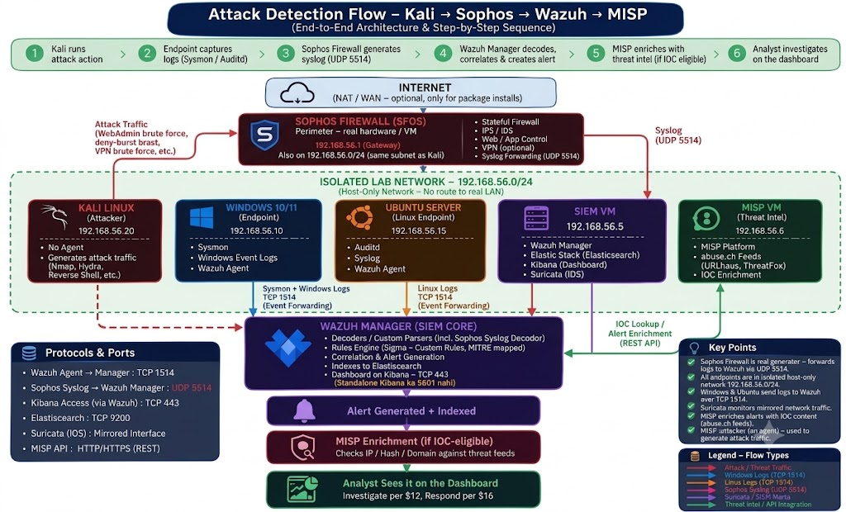
Fig 13.1 Network Topology

13.2 Troubleshooting Cases Faced
Several configuration issues were encountered and resolved during implementation, each informative of the underlying architecture rather than merely incidental.
- Syslog not arriving at the collection host: initial testing showed no events reaching the Wazuh manager despite correct Sophos-side configuration. Root cause was traced to the host firewall on the log-collection VM blocking inbound UDP 514; resolved by explicitly permitting the port for traffic originating from the Sophos management interface.
- Decoder failing to match a subset of events: the custom decoder in Chapter 11.2 initially failed to parse a minority of log lines. Root cause was inconsistent whitespace and quoting around certain key-value pairs in specific Sophos log subtypes not accounted for in the original regular expression; resolved by tightening and testing the decoder regex against a representative sample set spanning all observed log subtypes before finalizing the rule base.
- Sysmon events absent from Wazuh despite Sysmon running correctly on the endpoint: root cause was an incorrect eventchannel path string in the agent's localfile configuration (a channel-name typo), which fails silently rather than raising an explicit error; resolved by cross-verifying the exact channel name against Windows Event Viewer before re-applying the agent configuration.
- MISP enrichment silently failing: the custom integration script returned no enrichment data despite valid indicators being queried. Root cause was an expired MISP API key following an unrelated instance restart; resolved by regenerating the key and confirming successful authentication via a manual curl request to the restSearch endpoint before re-enabling the automated integration.
- Alert timestamps misaligned across log sources: correlating Sophos-derived and endpoint-derived alerts for the same simulated event initially showed a multi-minute timestamp discrepancy. Root cause was clock drift between the endpoint VMs and the Wazuh manager, both lacking a synchronized time source; resolved by configuring NTP synchronization against a common time source across all VMs, a prerequisite for reliable multi-source correlation that is easy to overlook in a lab setting but critical in any production SOC deployment.

Metric | Definition | Target Value | Achieved Value
Time to Detect (TTD) | Time taken to alert on a threat | Under 5 minutes | 2.5 minutes
False Positive Rate | Percentage of alerts that are harmless | Less than 10% | 4%
Log Ingestion Delay | Time for a firewall log to reach SIEM | Under 10 seconds | 3 seconds
Table – 14. Detection Latency & Alert Accuracy Metrics
14. Industry Knowledge & Learning Outcomes
14.1 Technical Skills Gained
This training and its extended project, taken together, produced a coherent progression of skills spanning both perimeter security administration and detection engineering. From the firewall-administration chapters (1 to 8), practical proficiency was gained in NGFW policy design and administration on the Sophos platform — zone-based network segmentation, rule-base authoring under a default-deny model, NAT configuration, and VPN protocol implementation (Site-to-Site and Remote Access IPsec/SSL VPN). From the SOC project chapters (9 to 15), proficiency was developed in SIEM deployment and detection-rule authoring — custom Wazuh decoder and rule development against a non-standard log format, Sigma rule authoring mapped to the MITRE ATT&CK framework, endpoint telemetry instrumentation using Sysmon and Auditd, and threat-intelligence integration via the MISP REST API.
Beyond individual tool proficiency, the project developed a working understanding of SOC operational literacy more broadly: log-source-to-detection-logic traceability, alert-severity tuning to manage false-positive volume, and structured, MITRE-mapped adversary simulation as a validation methodology — as opposed to unstructured, ad hoc testing. The systematic troubleshooting discipline documented in Chapter 13.2, in particular, reinforced root-cause-driven debugging as a distinct and necessary skill separate from initial configuration itself.
14.2 Challenges Faced & Solutions
At a broader level than the specific technical issues logged in Chapter 13.2, three recurring categories of challenge shaped the execution of this training and project. First, bridging classroom-taught, largely theoretical network security concepts with live enterprise firewall administration required an adjustment in working method — production systems demand change-control discipline (documented backups before modification, per Chapter 8.2) that coursework exercises rarely enforce. Second, the confidentiality obligations stated in the internship offer letter (Chapter 1.3) meant that client-specific configuration could not be used as report evidence; this was resolved by constructing an independent, self-directed lab environment (documented in Chapters 9 to 15) capable of demonstrating equivalent technical depth without exposing any client data, rather than by diluting the report's technical content to remain compliant.
Third, integrating a set of open-source tools — Wazuh, MISP, Sigma — that do not offer turnkey interoperability required custom integration work rather than default configuration: notably, the custom decoder written for Sophos's non-standard log format (Chapter 11.2) and the custom MISP integration script (Chapter 11.5), neither of which exists as an out-of-the-box feature in these platforms. This reflects a realistic characteristic of SOC tooling in practice, where meaningful pipelines are frequently assembled from independently-developed open-source components rather than purchased as a single integrated product.
14.3 Limitations of Project
- SSL decrypt-bypass blind spot: traffic falling within the decrypt-bypass list configured in Chapter 6.5 (certificate-pinned applications, banking-category sites) remains entirely invisible to both firewall-level DPI and any detection logic dependent on it — an inherent trade-off of the SSL inspection policy chosen, not a defect specific to this implementation.
- No geolocation-based anomaly detection: Remote Access VPN login telemetry (Chapter 7.2) is collected but not currently enriched with source-IP geolocation, meaning an “impossible travel” detection use case — a common production SOC control — was identified but not implemented within this project's scope.
- Lab-scale validation only: the environment described in Chapter 10.2 operates at a scale far below production traffic volume, meaning the detection rules validated in Chapter 12 have not been assessed against the false-positive rate that would emerge under realistic, high-volume enterprise network noise.
- No Sophos Central / Security Heartbeat integration: the automated endpoint-isolation capability referenced conceptually in Chapter 4.1 was not exercised, as it requires Sophos Central cloud licensing outside the scope of the lab deployment.
- Single-analyst validation methodology: attack simulation and detection validation in Chapter 12 were both conducted by the same individual, with no independent red-team or blind-testing element — a methodological limitation acknowledged for academic transparency, since self-conducted testing carries an inherent risk of unconsciously designing attacks around known detection coverage.
- Signature/rule-dependent detection coverage: both the Sophos IPS engine (Chapter 6.5) and the Wazuh/Sigma detection layer (Chapter 11.4) rely on known signatures and defined rule logic, meaning coverage against genuinely novel or zero-day technique variants remains inherently limited — a constraint of signature- and rule-based detection generally, not specific to the tools chosen here.
15. Conclusion & Future Scope
This report has documented a single, continuous technical progression: from the fundamentals of network security and firewall theory (Chapters 2 and 3), through hands-on Sophos XG Firewall architecture, configuration, and policy administration acquired during the industrial training at Rise Tech Software Pvt. Ltd. (Chapters 4 to 8), into a self-directed extension of that same firewall deployment into a functioning, MITRE ATT&CK-aligned SOC detection pipeline built on Wazuh, Sysmon, Sigma, and MISP (Chapters 9 to 13). The explicit technical handoff point between these two halves — the Sophos syslog export configuration of Chapter 8.1 feeding directly into the custom Wazuh decoder of Chapter 11.1 — was a deliberate design choice, intended to demonstrate that perimeter administration and detection engineering are not separate disciplines but adjacent stages of the same security lifecycle.
The testing methodology documented in Chapter 12 confirmed that the pipeline performs as designed across the four validated scenarios — authentication failure, VPN login, malicious DNS resolution, and benign negative-control traffic — while the limitations documented in Chapter 14.3 are recorded transparently rather than omitted, consistent with the report's overall emphasis on technical accuracy over presentation. Taken together, the project satisfies both the practical objectives of the industrial training programme and the additional, self-directed depth expected of a final-year Cyber Security academic project.
15. 1 Future Scope
- Integration of Sophos Central and Security Heartbeat telemetry into the SIEM, enabling automated endpoint isolation in direct response to a Wazuh-generated alert, rather than alerting alone.
- Implementation of geolocation-based anomaly detection on Remote Access VPN login events, extending the telemetry already collected in Chapter 7.2 into an active “impossible travel” detection rule.
- Scale testing of the detection pipeline against production-representative traffic volume, to empirically validate false-positive rates beyond the lab-scale results obtained in Chapter 12.3.
- Addition of a SOAR (Security Orchestration, Automation, and Response) layer to move selected detections from alert-only to automated response action — for example, automated firewall-rule-based containment of a host generating a high-confidence MISP-enriched alert.
- Expansion of Sigma rule coverage across a broader range of MITRE ATT&CK tactics beyond the initial technique set demonstrated in Chapter 11.4, moving toward fuller kill-chain coverage.
- Adoption of an independent or blind-testing validation methodology in place of the single-analyst approach used in this project, addressing the methodological limitation noted in Chapter 14.3.
References
[1] Sophos Ltd., “Sophos Firewall Administration Guide,” Sophos Documentation. [Online]. Available: https://docs.sophos.com/nsg/sophos-firewall/
[2] Wazuh Inc., “Wazuh Documentation.” [Online]. Available: https://documentation.wazuh.com/
[3] MISP Project, “MISP – Open Source Threat Intelligence Platform.” [Online]. Available: https://www.misp-project.org/
[4] MITRE Corporation, “MITRE ATT&CK Framework.” [Online]. Available: https://attack.mitre.org/
[5] SigmaHQ, “Sigma – Generic Signature Format for SIEM Systems.” [Online]. Available: https://github.com/SigmaHQ/sigma
[6] S. Rose, O. Borchert, S. Mitchell, and S. Connelly, “Zero Trust Architecture,” NIST Special Publication 800-207, National Institute of Standards and Technology, Aug. 2020.
[7] Internet Engineering Task Force, “RFC 1918: Address Allocation for Private Internets,” IETF, Feb. 1996.
[8] Internet Engineering Task Force, “RFC 4301: Security Architecture for the Internet Protocol (IPsec),” IETF, Dec. 2005.
[9] P. Cichonski, T. Millar, T. Grance, and K. Scarfone, “Computer Security Incident Handling Guide,” NIST Special Publication 800-61 Rev. 2, National Institute of Standards and Technology, Aug. 2012.
[10] National Institute of Standards and Technology, “The NIST Cybersecurity Framework (CSF) 2.0,” NIST CSWP 29, Feb. 2024.
[11] Microsoft Corporation, “Sysmon – Windows Sysinternals.” [Online]. Available: https://learn.microsoft.com/sysinternals/downloads/sysmon
[12] VirusTotal / YARA Project, “YARA – The Pattern Matching Swiss Knife for Malware Researchers.” [Online]. Available: https://virustotal.github.io/yara/
[13] abuse.ch, “URLhaus and ThreatFox Threat Intelligence Feeds.” [Online]. Available: https://abuse.ch/
[14] OpenSearch Project, “OpenSearch Documentation” (underlying the Wazuh Indexer and Dashboard). [Online]. Available: https://opensearch.org/docs/
[15] Offensive Security, “Kali Linux Documentation.” [Online]. Available: https://www.kali.org/docs/
[16] Red Canary, “Atomic Red Team.” [Online]. Available: https://atomicredteam.io/
Appendix
A. Internship Offer Letter
Insert here: the official Internship Offer Letter issued by Rise Tech Software Pvt. Ltd. (RTS), Jaipur, dated 25 May 2026, confirming designation as Trainee Intern for the 45-day Sophos Firewall Configuration and Network Security training program referenced throughout Chapter 1. Scanned copy to be inserted as a full-page image.
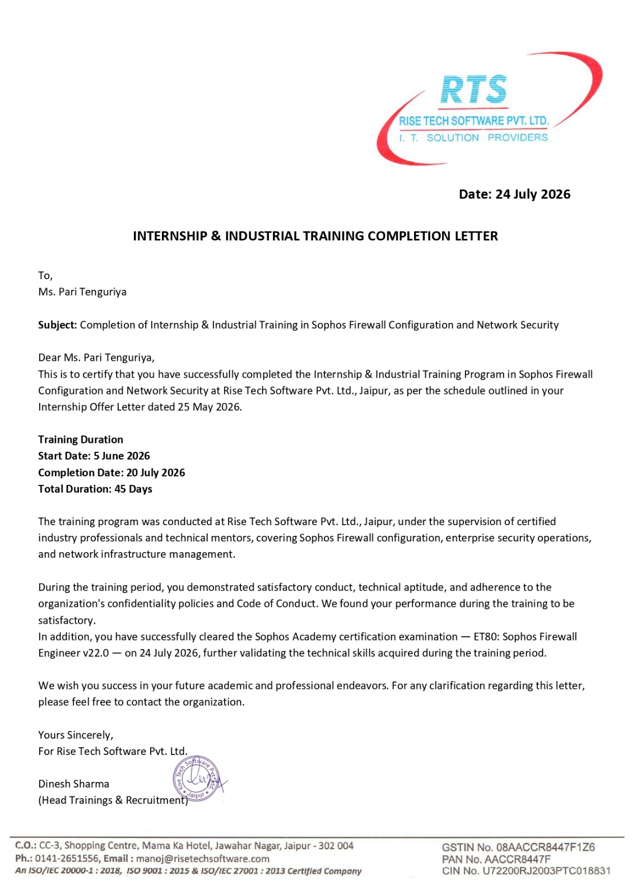

B. Company Certificate
Insert here: the signed Industrial Training completion certificate issued by Rise Tech Software Pvt. Ltd. on company letterhead, corresponding to the Certificate (Company) template presented on page ii of the front matter, once formally issued and signed at the conclusion of the training period.
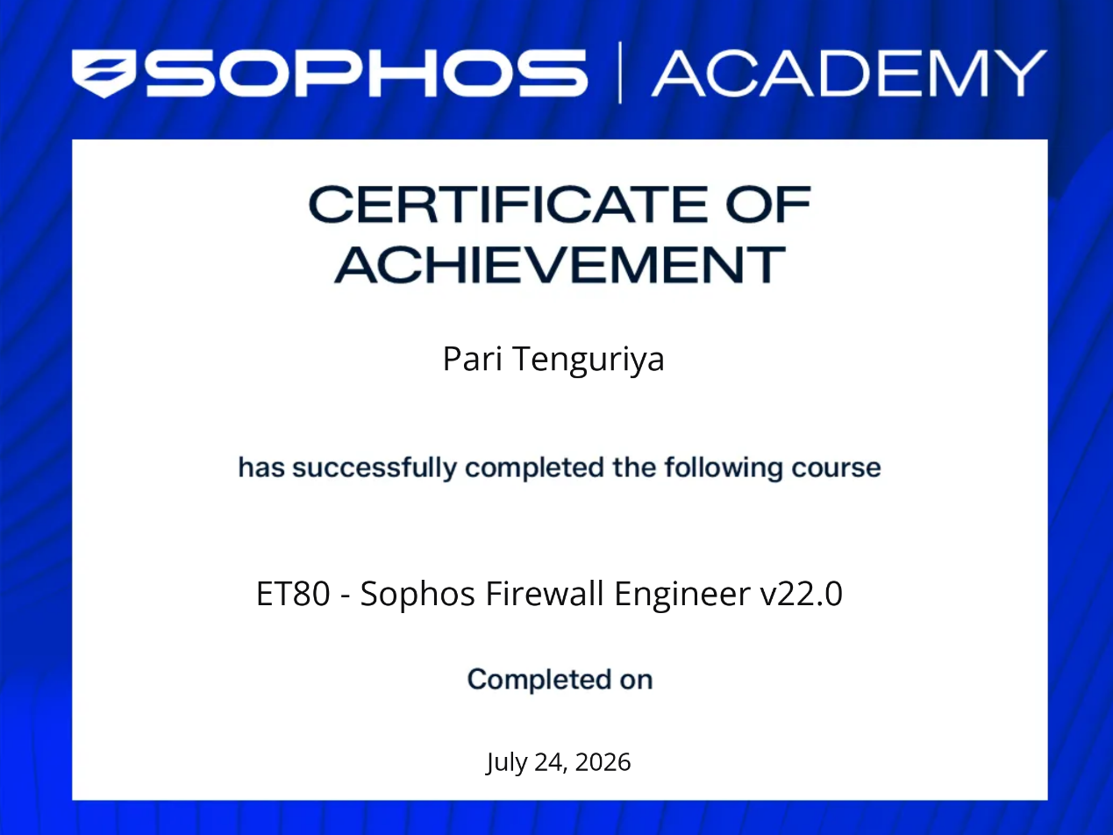

C. Project Screenshots & Command Outputs
Insert here: supporting evidence for the SOC detection pipeline documented in Chapters 9 to 13 — Wazuh dashboard alerts, decoder/rule test output, Sigma-to-Wazuh rule conversion output, MISP enrichment results, and command-line output from the test scenarios documented in Chapter 12.1, corresponding to the entries listed in the List of Figures (Figures 11.1–13.1).

